Week 11
Monday 1st June 2020
English comprehension – Year 1 & 2
Captain Tom Moore
Captain Tom Moore is famous around the world because of the money he has raised for the National Health Service (NHS).
Who Is Captain Tom Moore?
Captain Tom is an ex-soldier from Bedfordshire. When he was younger, he was in the army and even fought in the Second World War.
Raising Money
Captain Tom decided to raise money for the NHS to say thank you to them. He set himself the challenge of walking 100 laps around his garden before his 100th birthday on 30th April 2020.
Why Is He Famous?
Captain Tom set himself a target of £1000, but word quickly spread about what he was doing and more and more people gave money.
So far, he has raised over 27 million pounds! He even reached 100 laps two weeks before his birthday.
Did You Know…?
Lots of people have sent him birthday cards to say thank you.

Captain Tom Moore Questions
- Where does Captain Tom live? Tick one.
Bedfordshire
Dorset
London
- When is Captain Tom’s birthday? Tick one.
June 30th May 30th April 30th
- Who is Captain Tom raising money for? Tick one.
The NHS
Animals
Children
- How much money has Captain Tom raised? Tick one.
1 million pounds
Over 27 million pounds
10 million pounds
- How did Captain Tom raise money? Tick one.
- Walking
Swimming
Cycling

Week 11
Tuesday 2nd June 2020 English Spag – Year 1 & 2

Spelling, Grammar and Punctuation

LO:To use join words and clauses
Task 1
Can you complete the sentences to describe what each child saw at the zoo? Remember to use the word and to join the two animals together
Look at my example below
I went to the zoo and I saw a giraffe and Koala bear.

I went to the zoo and I saw _________________________________.
I went to the zoo and I saw _________________________________.
I went to the zoo and I saw _________________________________.
I went to the zoo and I saw _________________________________.
Task 2:
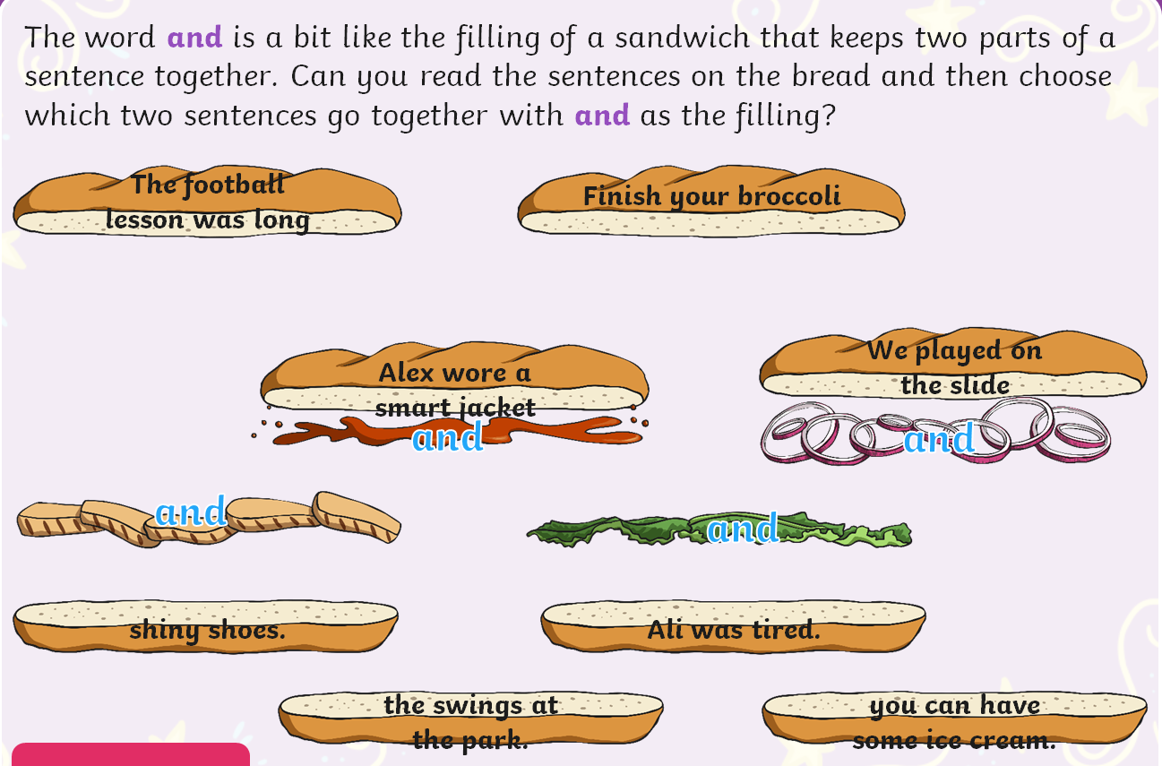

Week 11
Tuesday 2nd June 2020
Spellings
Write and learn the following words in your book.
Write the words 5 times.
Use each word in a sentence.
Do not forget to use a capital letter and full stop in your sentences.
Challenge- Can you use at least 2 of the words from the list in a sentence?
Example- My brother won't be there.
- won't
- gone
- many
- there
- brother
- bright
- doing

Week 11
Wednesday 3rd June 2020
English writing – Year 1 & 2
Enjoy the animated reading of This is the House that Jack Built by Simms Tabac at https://www.youtube.com/watch?v=qYymDq0muDI (6 mins long).
  - Pause at 4.40. Who do you think the mystery guest is going to be?
  - Finish the story and find out!

Recalling and sequencing details from the story
The story has 6 different animals in it. Can you remember all of them and the order they appeared in?
  - On Story Animals, write the names of all the animals from the story that you can remember.
  - Check on the Characters mini poster to see how many you got right.
  - Give yourself 1 point for every animal you remembered. You get 2 extra points if you got all of them. You get 5 extra points if you managed to get all the animals in the right order. What’s your score?

Let’s get ready for writing
Read the lines at the top of Animal Sentences (This is the sneaky rat. It eats some stinky cheese). Notice the describing words used for rat and cheese.
  - Write your own sentences, following the instructions.

Now try these Fun-Time Extras
- Label the picture of Jack's House (pink front door, tall chimney, etc.)
- Draw your own version of Jack's strange house!

Story Animals

Number | Animal
1
2
3
4
5
6

My score was:

Characters

Number | Animal
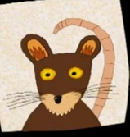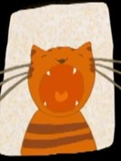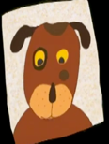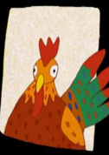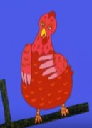1

rat
2

cat
3

dog
4

cow
5

rooster
6

little red hen

Animal Sentences

Instructions
  - Write your own sentences like these for 3 other animals in the story.
  - Use a describing word for each animal or thing in your sentences.
  - Make sure you use good finger spaces. Use a capital letter at the start of your sentences. Put a full stop at the end of each sentence.

This is the sneaky rat.
It eats some of the stinky cheese.

Jack’s House

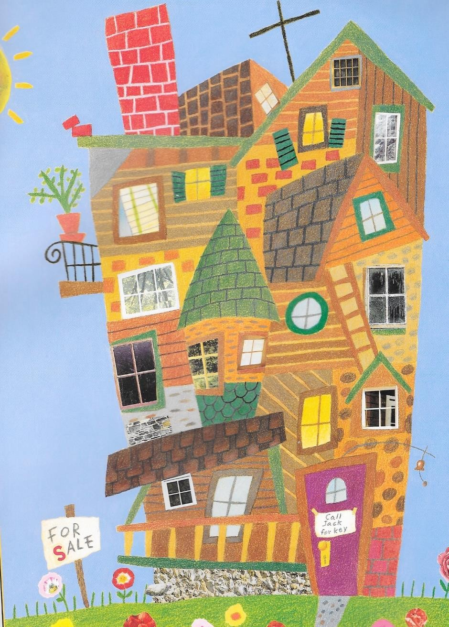

Thursday 4th June 2020
Reading and book review – Year 1 & 2
Fish Friends Three Written By: Sheila Gandhi (click on the link below to listen to it)
https://stories.audible.com/pdp/B085K1FZBG?ref=adbl_ent_anon_ds_pdp_pc_pg-1-cntr-0-22 Answer these questions below
What did you like about the book?

What was your favorite part? (Describe)

Who was your favorite character and why?

Draw a picture of your favorite scene.

Yr 2 challenge: What rating would you give out of 10 for this book and why?
Week 11
Friday 5th June 2020
English spelling
Spelling
Write and learn the following words in your book.
Write the words 5 times.
Use each word in a sentence.
Do not forget to use a capital letter and full stop in your sentences.
Challenge- can you use a comma in your sentences?
Example- Look again, mother and father are here.
- them
- mother
- father
- tell
- look
- again
- going

