Summer 2
Rec Maths

Notes for parents
(Remember gold prizes from me for neat outstanding work)

If you do not have access to a printer, provide your child with an exercise book to do their work in.

- Write the short date (today's date)
- Write the L.O:
- Miss a line
- Question numbers in the margin and write answers on the line.

(I will be asking your parents if your work looks neat and to send me a picture of your amazing work. I myself will check your work once you come back to school in sha Allah)

Monday 1st June 2020
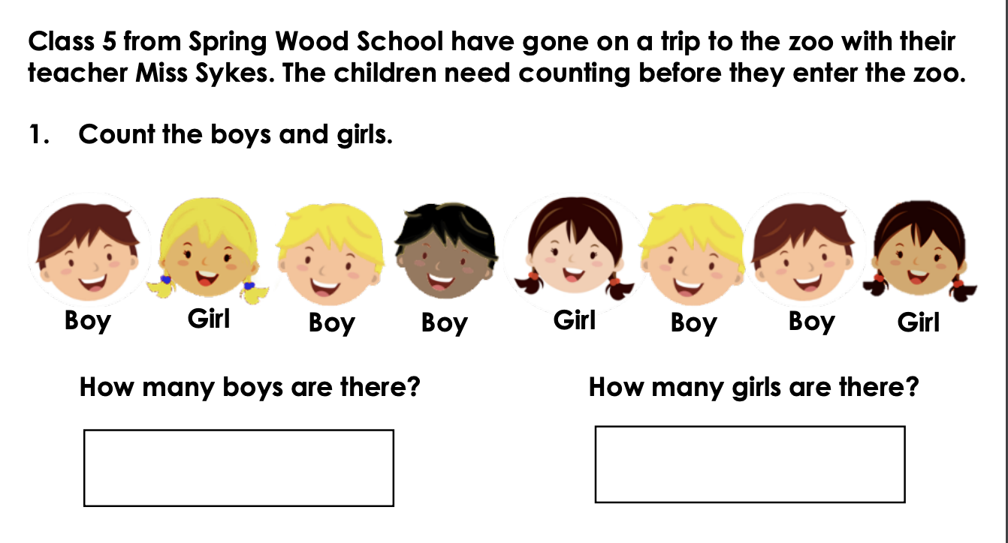

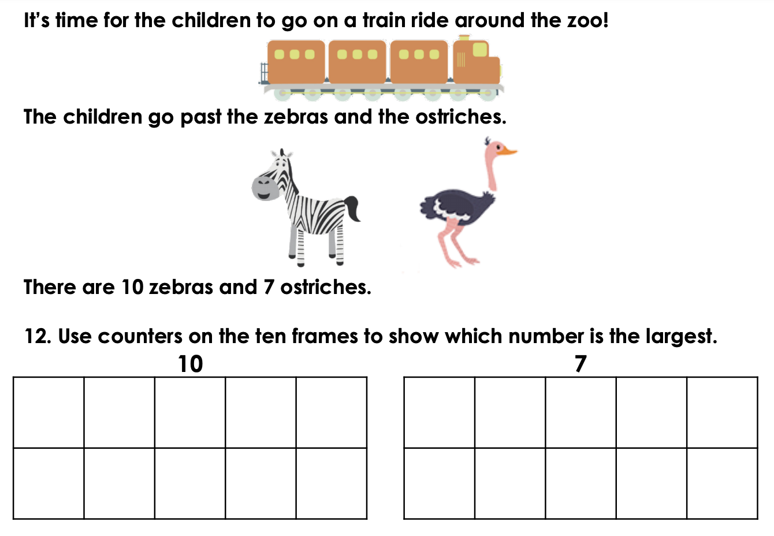

Tuesday 2nd June 2020

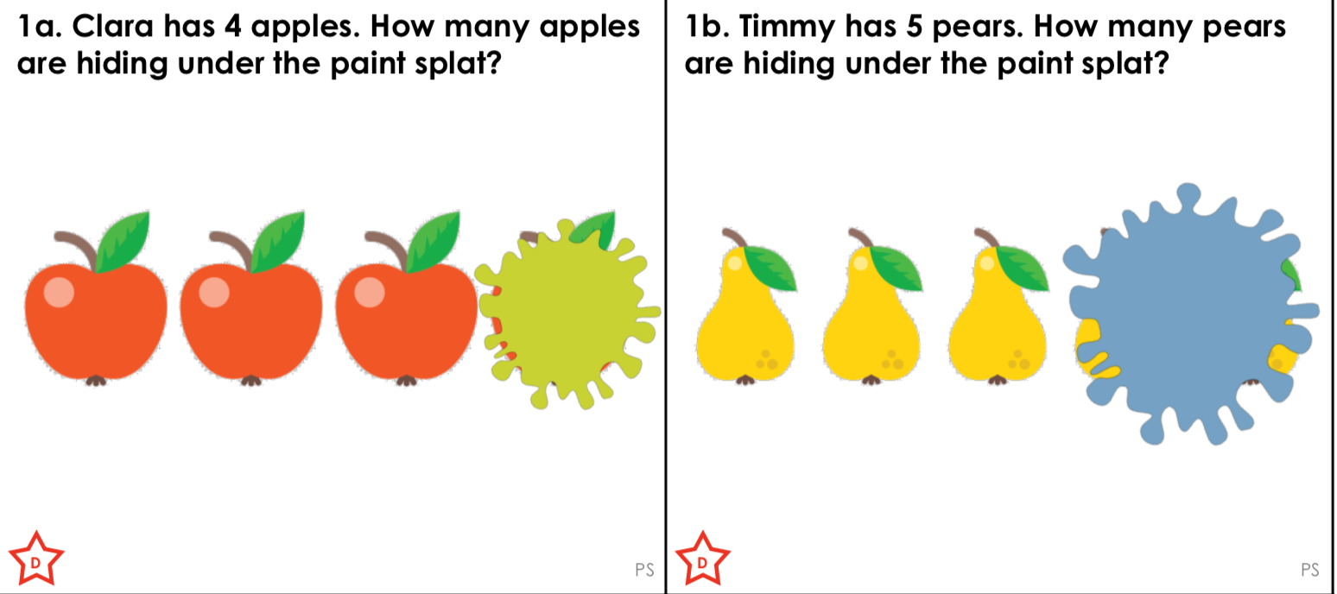

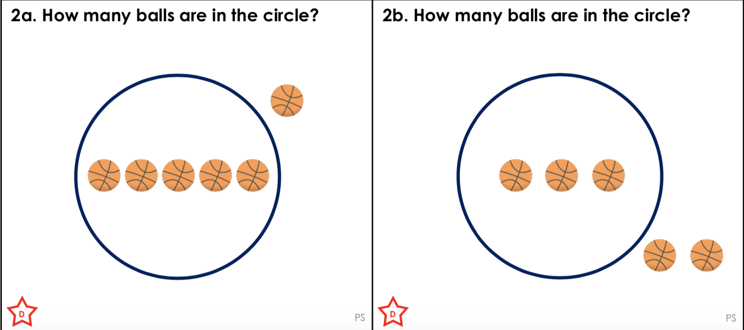

Wednesday 3rd June 2020
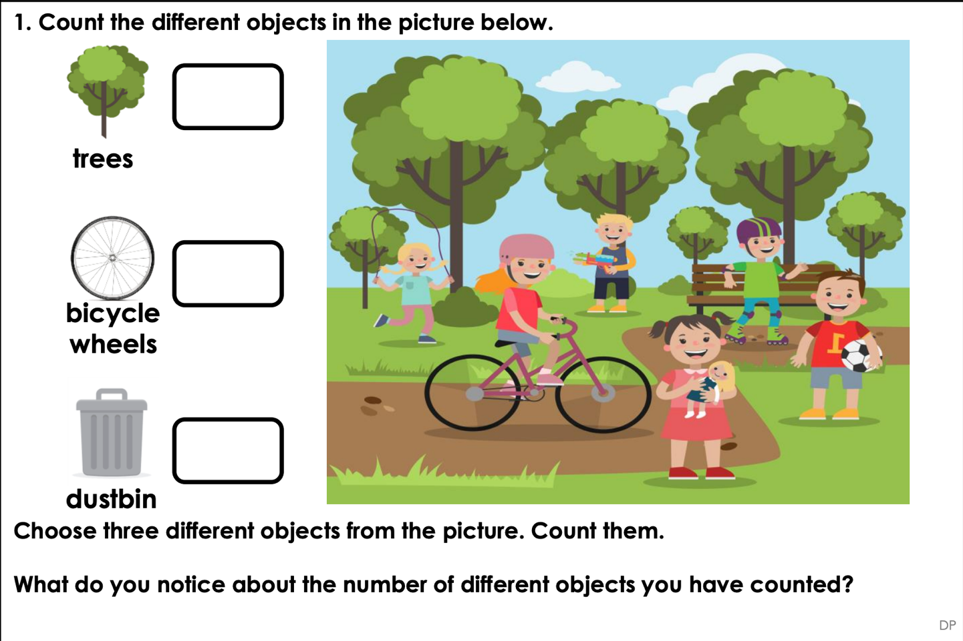

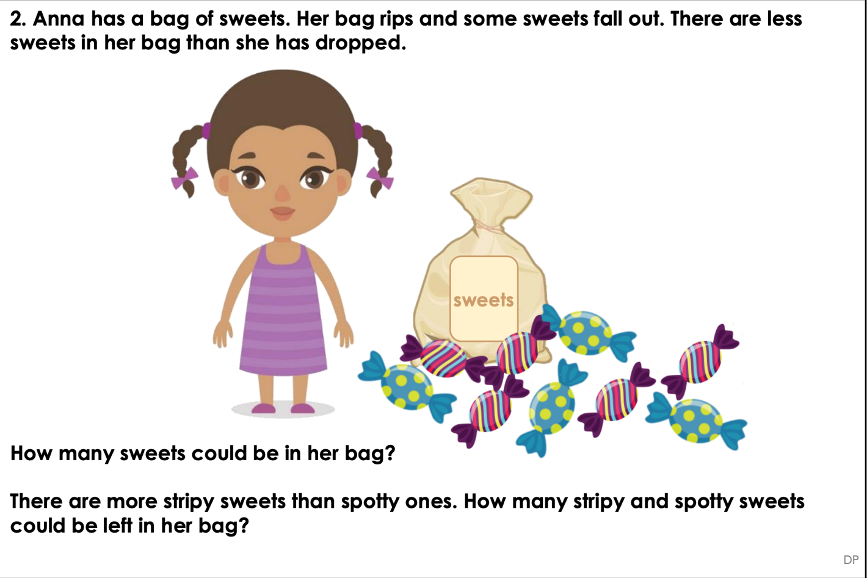

Thursday 4th June 2020
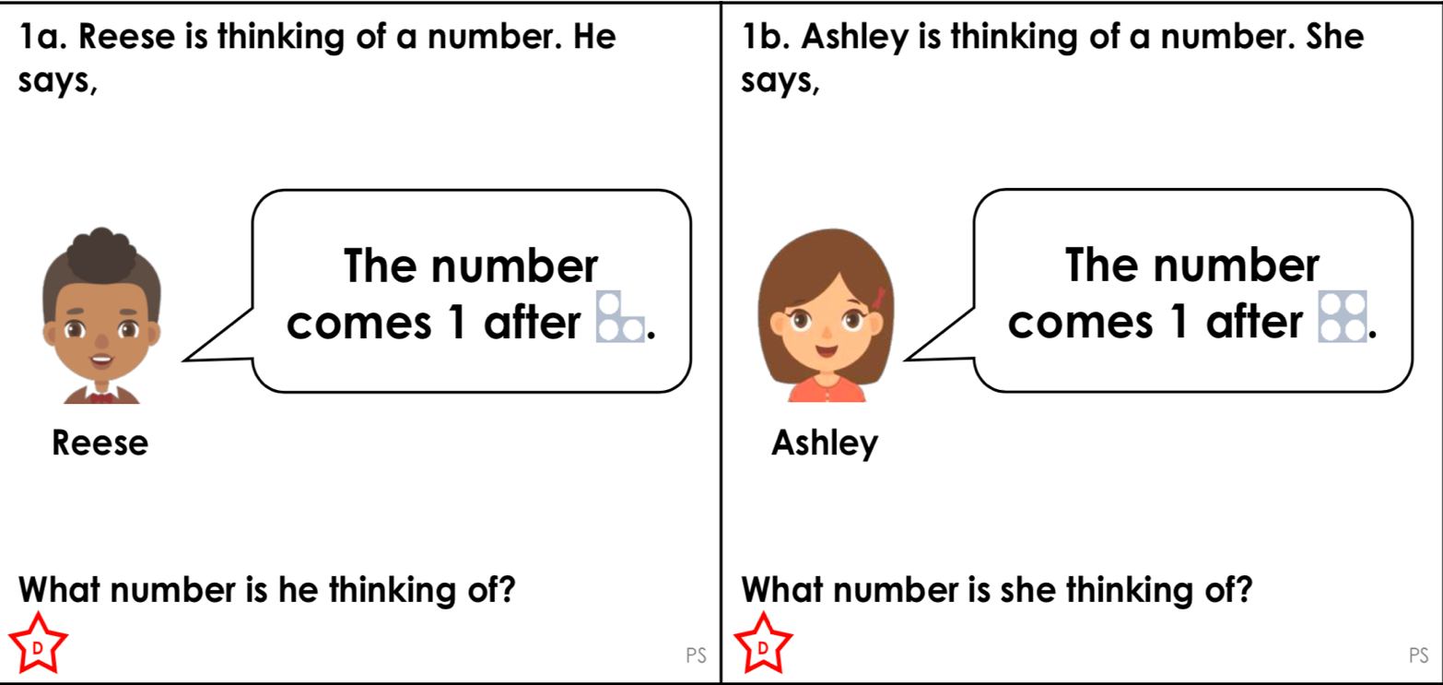

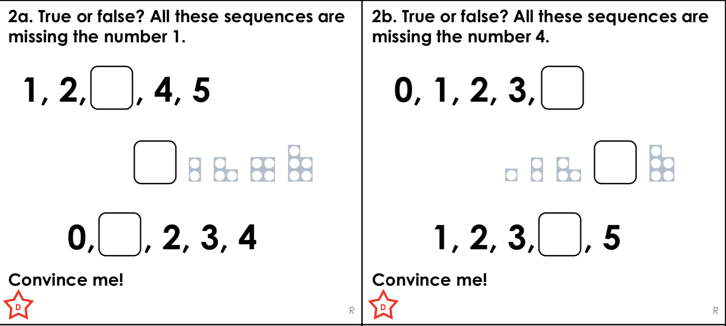

Friday 5th June 2020

