Phonics Phase 1: Alliteration - week 11
Model as per example below to teach your child the letter and the initial sound it makes. Ask your child to name each letter and the initial sound then say the sound and the pictures. Write each letter out showing them how to hold the pencil in a tripod grip. You can use dot-to-dot to start with but eventually they should be able to copy it by themselves. Children to also practice writing their name.

E.g- This is the letter 'm'. It makes the initial sound 'm'.
q, q, que q, q, quilt q,q, queen
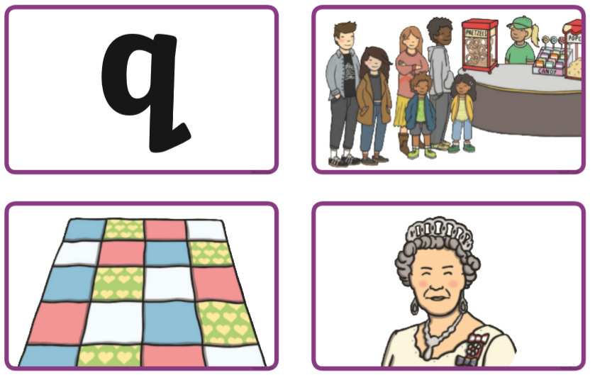

This is the letter 'n'. It makes the sound 'n'
r,r, rabit r,r, rainbow r,r,rat 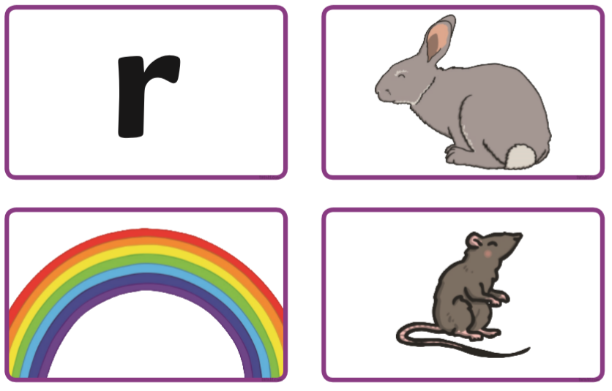

This is the letter 'o'. It makes the sound 'o'
s,s, sun s,s, saw s,s, sandwich
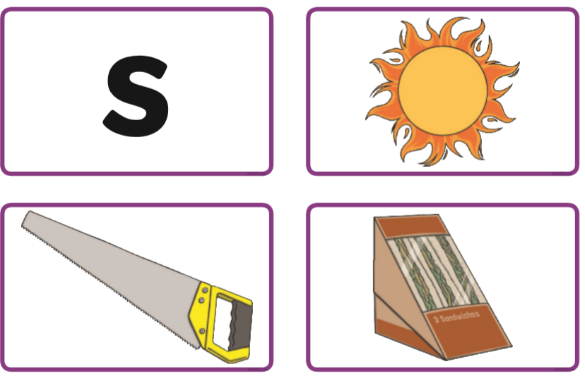

This is the letter 'p'. It makes the sound 'p'
t,t, torch t,t, tent t,t, turtle
