Build your own Mosque

To help children become attached to the mosque, it's great to make your home into a masjid. Whilst you’re in lockdown why not try some of these mosque crafts to create your own little masjid at home! These ideas are all so fun and a great way to help strengthen your little ones identity as a Muslim. See below ideas for inspiration...

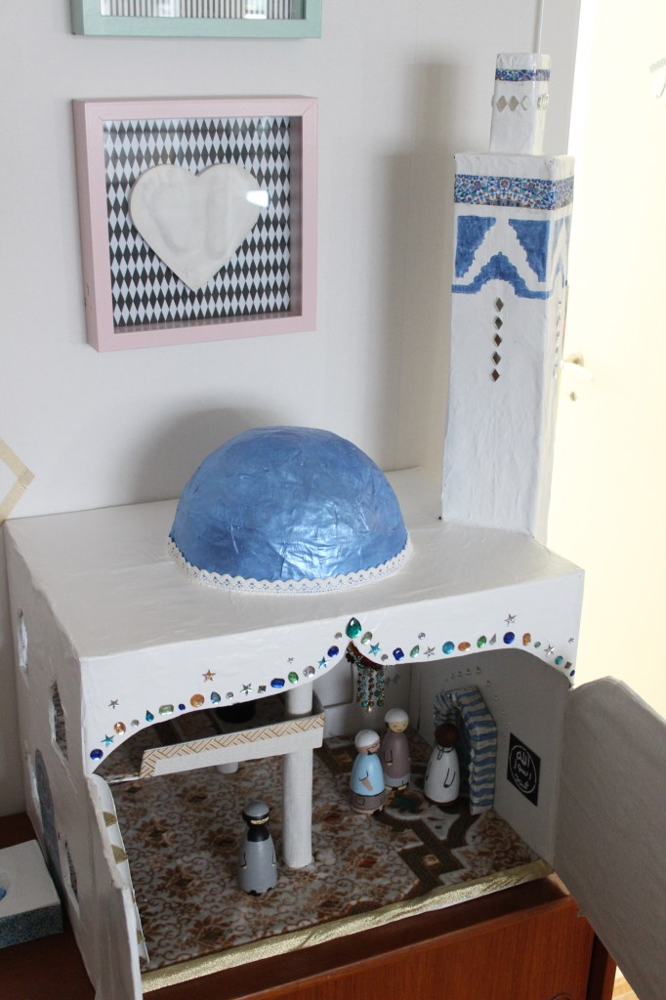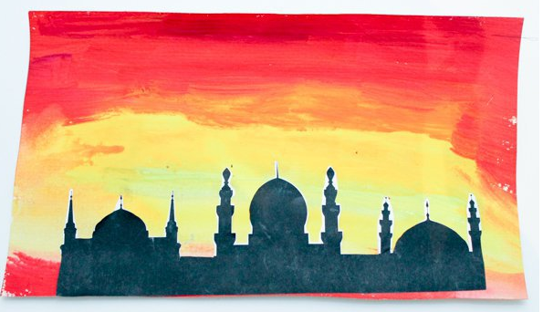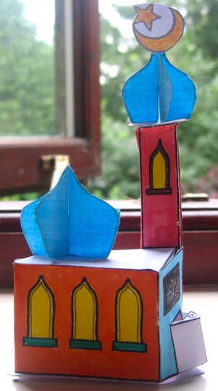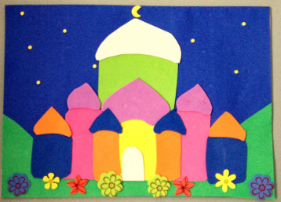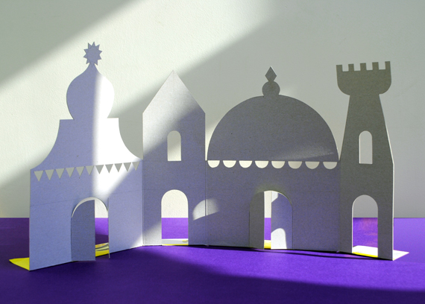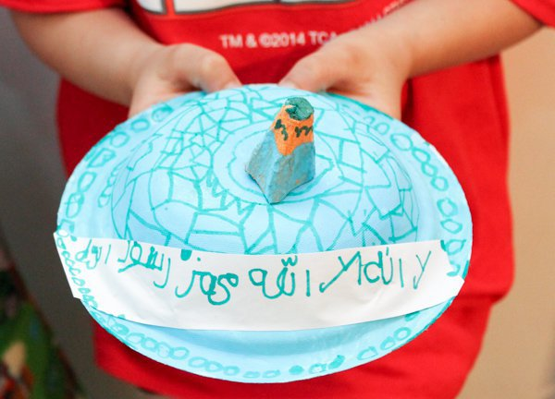

Materials that can be used:
Junk Modeling
Construction paper
Tissue paper
Paint
Glue
Scissors
Black marker
Pencil / Colouring Pencils

To make this masjid follow the below instructions...
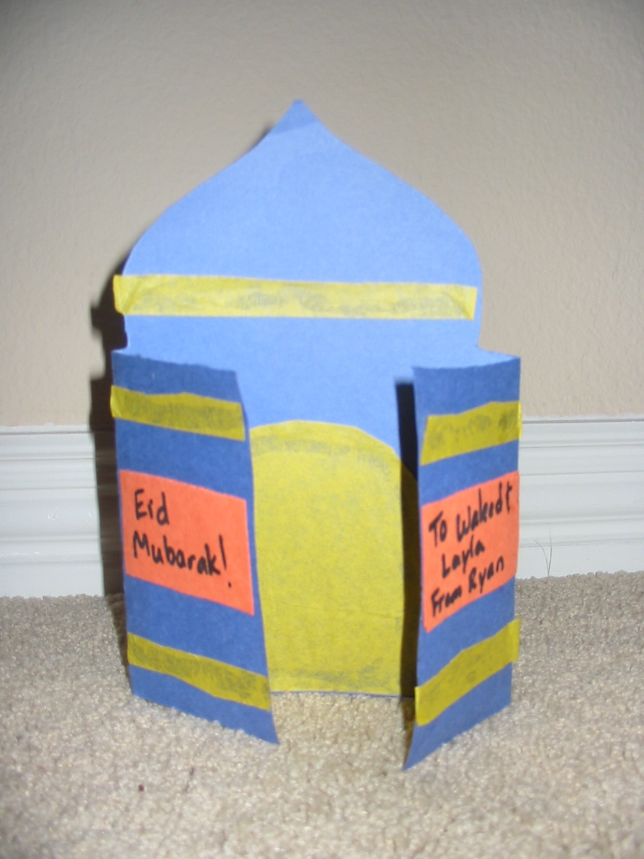
Directions:
1. Use a pencil to mark the middle of a piece of construction paper. This should be about 6 inches from each end of the paper.
2. Fold the ends of the paper so that they meet in the middle.
3. Cut a dome over the middle section, and cut off the tops of the end sections that are folded over.
4. Cut doors and stripes out of tissue paper. Glue the doors inside the card, and the stripes along the top of the dome and on the outside of the card.
5. Write a message on a piece of construction paper like, “Come and pray in my Masjid” or name your masjid using your child's name 'Bilal's Masjid'. Cut it out and glue it on the doors.

Build a Mosque In This World And Build Your Palace In Jannah!

