Monday 20th April 2020
Year 3 & 4
3 Times Table 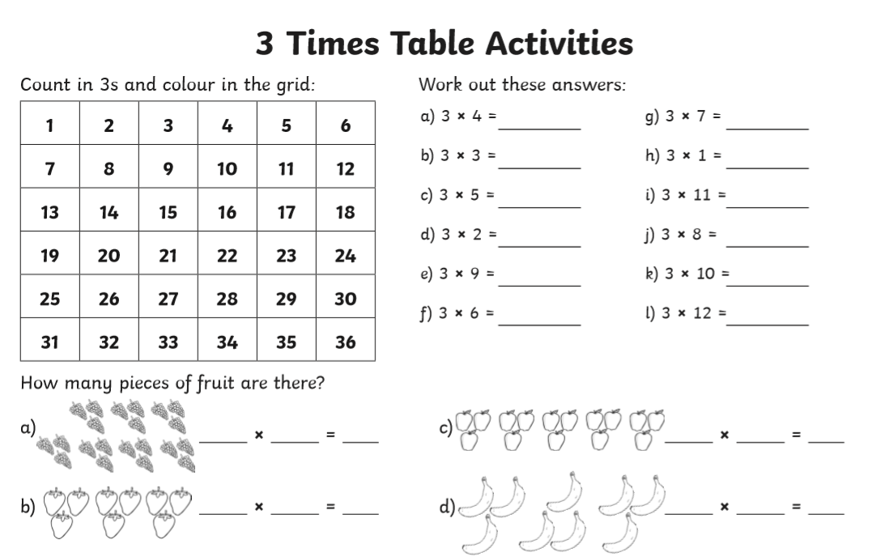
Year 4 Challenge:
