Week 5
Monday 20th April 2020
English comprehension – Year 3 & 4

LO: To answer reading comprehension questions by deducing and inferring information.
Read the extract. Read the question and highlight the answer. Write the answer in full sentences.

The old railway yard
Jack was scared. He was walking through an abandoned railway station on his way home. He came this way because it was a lot quicker but he was regretting his decision. His hairs on his neck were stood up like soldiers in a parade. His heart was racing and his stomach churned. As he paced through the creepy yard he tried to stay under the colossal shadows of the huge, ancient steam trains.
Then something strange happened. A light appeared in one of the driver carriages of the train. Hesitantly, Jack stopped and looked back. He could not see anyone in the driver’s carriage! Jack had a decision to make. His head told him to go back home and get out of their as quickly as possible. His heart told him to go and explore the strange light!
Jack made his decision. He sprinted over to the carriage and heaved the door open. It creaked loudly and some dust dropped onto the floor. Jack started to walk through the old carriage which had rotten floorboards. As he got to the old fashioned handle that led into the driver’s compartment, he paused for a moment. He took a deep breath and opened the door.
The air was still. The smell was dusty. The light flickered. Flick. Flick. Flick. But nobody was there. All of a sudden a defeating clank sounded. Jack looked out of the window and saw a tree move sideways. Then Jack had a realisation! It wasn’t the tree moving, it was Jack. It was the train! The train was slowly winding down the track. Steam started to chug. Faster the train went. Faster and faster!
“How can this be?” whispered Jack to himself in amazement! He was sure he was the only person on the train.

Questions- Year 3 can answer questions 1 to 5
Year 4 should attempt to answer all the questions.
- Please answer in full sentences e.g. What signs are there that show us Jack was scared?
- Answer- The signs that show us that Jack was scared were …

- What signs are there that show us Jack was scared?
- Look at paragraph One. It tells us Jack tried to stay under the shadows of the train. Why do you think he tried to do this?
- What two words in the first paragraph tell us the trains are big?
- What word in paragraph 2 tells us Jack was uncomfortable?
- Draw and fill in a thought bubble about how Jack might have been feeling at the end of Paragraph 2. Use as much detail as you can.
- There are clues in the text that tell us the steam trains were old. Can you spot them all?
- Why do you think Jack paused before opening the door to the driver’s compartment?
- What emotions would Jack be feeling in the final paragraph? Explain fully how you know or think this.
- What features are there that make this text a mystery story?

Week 5
Tuesday 21st April 2020
Grammar and Spellings
LO: To be able to use the right verb in a sentence
Read the sentence carefully and put the correct verb in the correct places. Present your work neatly and don’t forget your capital letters and full stops which you practised last week. Bismillah!
Add the correct verb to the sentence. Was/were
Example: We ______ playing nicely. I ______ only joking!
Answer: We were playing nicely. I was only joking!
The following personal pronouns use:
Were
We/you/ they
The following personal pronouns use:
Was
I/ she/he/it

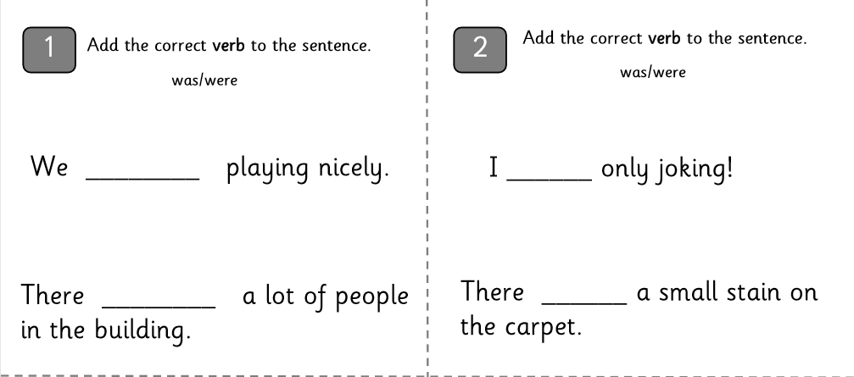

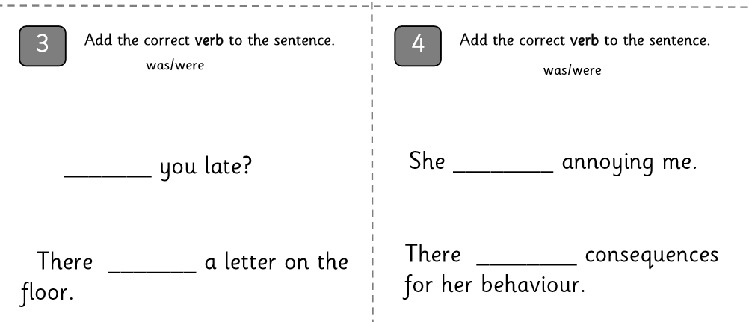
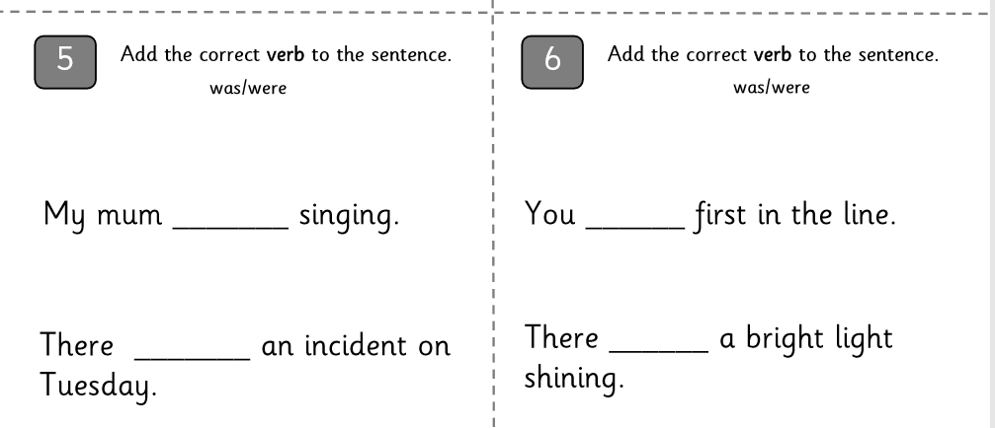

Challenge: Can you write your own sentences using the correct verb with the personal pronouns.

Week 5
Tuesday 21st April 2020
Spellings
Write and learn the following words in your book.
Write the words 5 times.
Use each word in a sentence.
Do not forget to use a capital letter and full stop in your sentences.
Challenge- can you use at least 2 of the words from the list in a sentence?
Example- I was busy riding my bicycle down the road.
- believe
- bicycle
- breath
- breathe
- build
- busy
- business
- calendar

Week 5
Wednesday 22nd April 2020
English writing – Year 3 & 4: Task- Design your ideal classroom and write what would you include and why? Look at Dash’s classroom and get some ideas and the questions below will give you some guidance. Finally, compare your classroom with DASH’s. What are the similarities and differences?
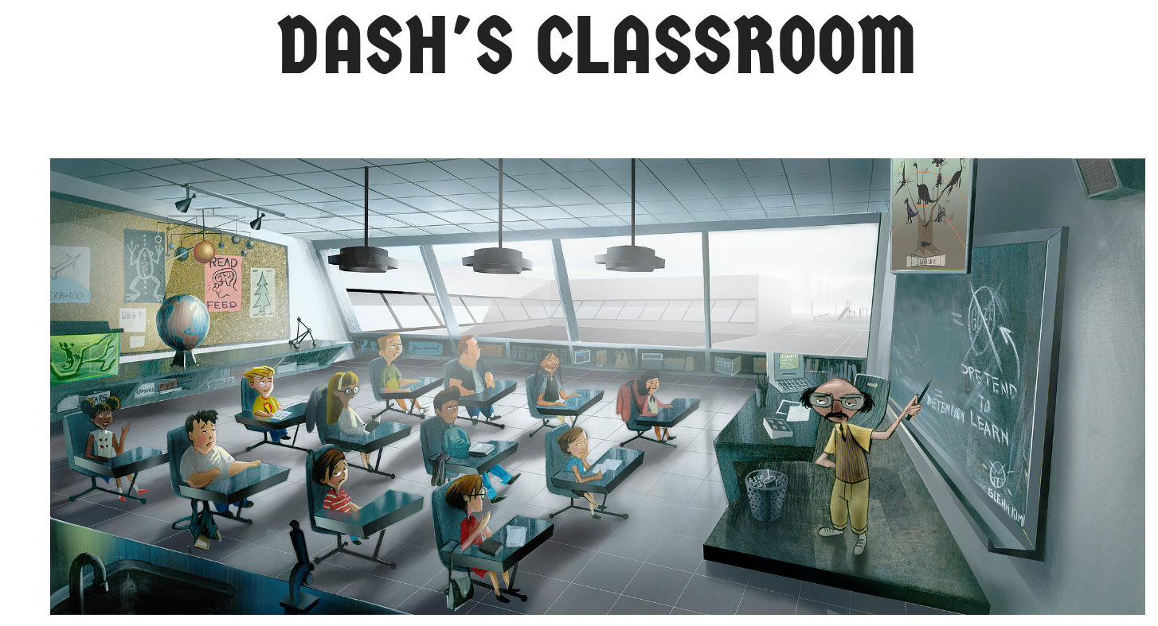
These questions will help you:
- What equipment would you like to have in your class? Different subjects need different resources.
- What subjects would you like to teach in your class?
- How would like to make your class interesting so the children become engaged in their learning?
- How can you make the learning environment fun for the students? Think about displays on the walls
- Compare Dash’s classroom to your own. What’s similar and what’s different?
- What should a classroom look/sound/feel like? Should all classrooms look the same? Why?
Do not forget to:
- Use capital letters and full stops.
- Include lots of adjectives (describing words) and adverbs (to describe the verbs)
- Read each sentence to check if it makes sense.
- Open sentences in a wide range of ways for interest and impact.
- Use a wide range of punctuation including at least 3 of the following: full stop and capital, question mark, exclamation mark, apostrophe and comma.
- Use more sophisticated connectives, (e.g. although, however, nevertheless, despite, contrary to, as well as etc).
- Use paragraphs although may not always be accurate.
- Use nouns, pronouns and tenses accurately and consistently throughout.

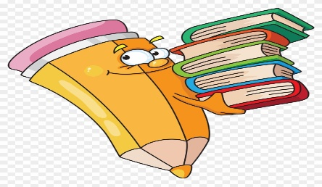
Week 5
Thursday 23rd April 2020
Reading and book review – Year 3 & 4
Choose a book to read and answer the following questions about your book.
Book review by: ________________________________________________________
Title:_____________________________________________
Author: ___________________________________________
Non-fiction Fiction
What is the book about?
______________________________________________________________________________________
_____________________________________________________________________________________
Who would this book be suitable for? Age/interests

______________________________________________________________________________________
What was your favourite part? (Describe)
______________________________________________________________________________________
Year 4 challenge: Would you/would you not recommend the book to someone else? Why?

Week 5
Friday 24th April 2020
Comprehension: Read the information text and answer the questions in your home learning book. Make sure you date your work and write the title. Remember answers should be written in full sentences.
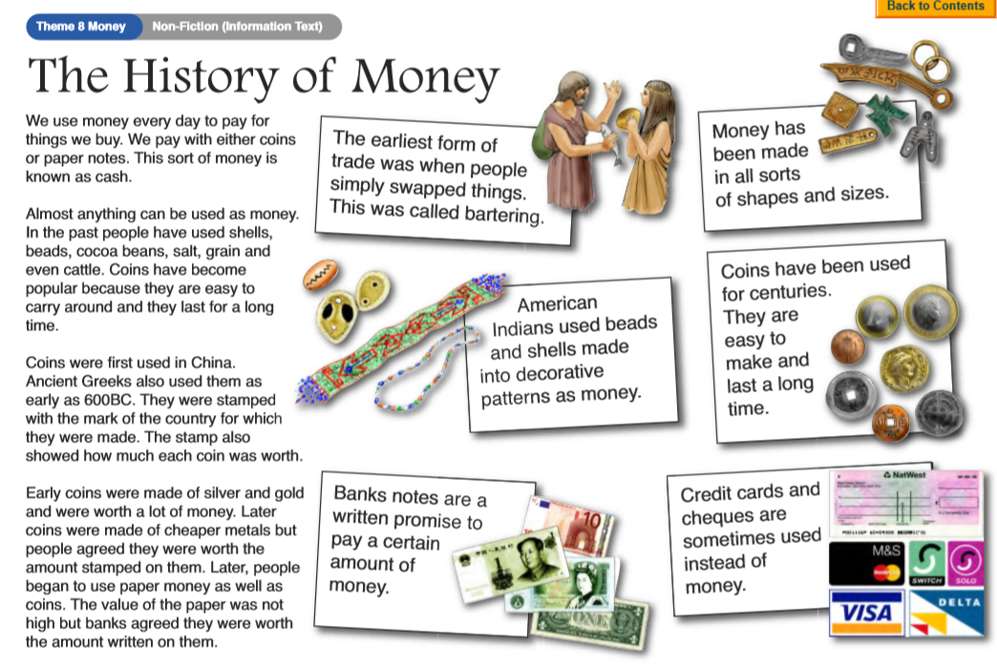

Questions:

  - What is money used for?

  - What are coins and paper notes known as?

  - Name two things that were used as money before coins?

  - Which was the first country to use coins?

  - What were the early coins made from?

  - Why do you think later coins were made from cheaper materials?

  - Why were coins a popular form of money?

  - Why do you think paper money is now used as well as coins?

Year 4 challenge: Wrote a list of all different types of coins and notes you can think of.

