Week 5
Monday 20th April 2020
English comprehension – Year 1 & 2
Mary Seacole
Mary Seacole was born in 1805 in Jamaica. Her mother was Jamaican. Her father came from Scotland. Mary learned to read and write. She learned from her mother how to make medicines from herbs. She pretended her doll was sick and gave her medicines.
In 1853, there was a war between Russia and the United Kingdom and France. Lots of men went to fight in the war. Many of them got sick or hurt and died. The British sent nurses out to look after the men. Florence Nightingale was in charge. Mary Seacole wrote a letter to ask to be one of the nurses, but she was told ‘no.’
When there were battles, Mary would go and find men who were hurt and treat their wounds. The soldiers were very grateful for this. She was given medals for being so brave.
When the war ended, Mary came back to England. She had no money left. Some soldiers raised money for her to say thank you for helping them.

Questions- Year 1 can answer questions 1 to 6
Year 2 should attempt to answer all the questions.
Please answer in full sentences e.g. Which year was Mary Seacole born in?
Answer- Mary Seacole was born in 1805.

- Where was Mary Seacole born?
- How did Mary Seacole learn about medicines?
- Find two adjectives in the text.
- Why did the nurses go to the Crimean War?
- What happened when Mary asked to be a nurse in the Crimean War?
- How did Mary go to help in the war?
- How do we know that Mary was brave?
- How did the soldiers say thank you to Mary?
- What adjective would you use to describe Mary and why?
- Is a nurse really important these days and why? Think about what is happening in the world at the moment.

Week 5
Tuesday 21st April 2020
English Spag – Year 1 & 2
Adjectives
LO: To recognise adjectives

Write the adjectives from the sentences in your book. Remember, adjectives are describing words.
- In a dingy forest, there lived an enormous Giant.
- The pink glitter sparkled on her beautiful costume as she walked down the street.
Circle and write down the 3 adjectives below.
A. banana
B. furry
C. football
D. dark
E. exciting
F. box

Write 5 adjectives to describe this picture.

Challenge: Write 4/5 sentences about this picture using as many adjectives as you can.

Do not forget, your sentences need to start with a capital letter and end with a full stop!
Example- The trees are covered in white, silky snowflakes.

Week 5
Tuesday 21st April 2020
Spellings
Write and learn the following words in your book.
Write the words 5 times.
Use each word in a sentence.
Do not forget to use a capital letter and full stop in your sentences.
Challenge- Can you use at least 2 of the words from the list in a sentence?
Example- I saw an old man as I walked by.
- an
- as
- by
- not
- off
- old
- out
- saw
Week 5
Wednesday 22nd April 2020
English writing – Year 1 & 2
Task- Write a short description about a girl who is in the room below. Use the questions below to help you describe why she is in this room all by herself.
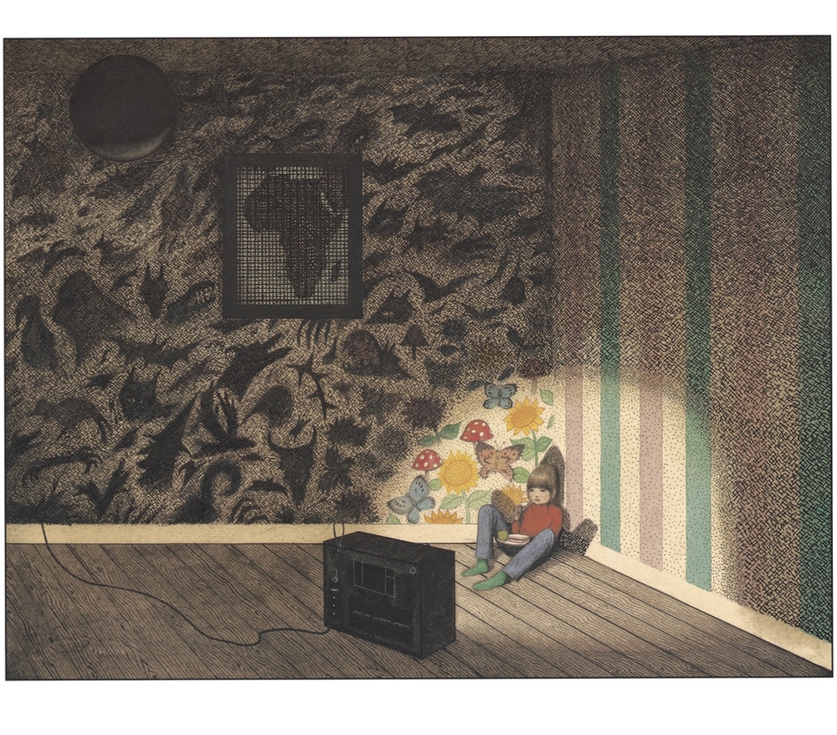
Do not forget to:
- Use capital letters and full stops.
- Finger space between each word.
- Include lots of adjectives (describing words)
- Describe how the girl felt.
- Read each sentence to check if it makes sense.
- Provide enough detail to interest the reader, (e.g. is beginning to provide additional information or
- description, beyond a simple list).

Word bank for Yr1 & 2
upset floor dingy mum dad light television unhappy empty locked withdrawn sad grumpy wallpaper frame window miserable escape

Sentence starters for you to use-

This is Kyla who is sitting down on the ........of a dark room all by...........
She lives in a........with.....
She is in the room because…...
Kyla seems to have her eyes focused on..........
The room looks.....
I think there is little light because......
To me it seems, she is quite upset as.....

Week 5
Thursday 23rd April 2020
Reading and book review – Year 1 & 2

The Lion and the Mouse Written By: Lavanya R. N
One day, a lion was asleep in the wood. A mouse came along. The mouse didn’t see the lion and ran across the lion’s nose. The lion woke up. He was cross with the mouse. “You woke me up!” he roared. The mouse was scared. “Please let me go!” said the mouse. “If you let me go, I will repay you one day!” “You are funny!” said the lion. “How could a mouse help a lion?” The lion laughed and let the mouse go home. Some days later, the lion was caught in a hunter’s net. He couldn’t get out. The lion roared in anger.
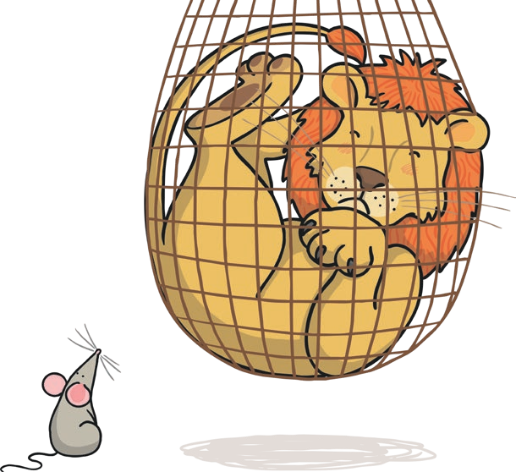
The mouse heard the lion and ran to the net. The mouse saw the lion and had an idea. She chewed on the net until it broke and the lion fell out. The lion was free. “Even A mouse can help a lion!” said the mouse. From that day, the mouse and the lion became friends. A kindness is never wasted.
Read the story of the Lion and the Mouse and answer the following questions about the book.
Title:_____________________________________________
Author: ___________________________________________

What did you like about the book?

What was your favourite part? (Describe)

Who was your favourite character and why?

Draw a picture of your favourite scene.

Yr 2 challenge: What rating would you give out of 10 for this book and why?

Week 5
Friday 24th April 2020
English spelling
Spelling
Write and learn the following words in your book.
Write the words 5 times.
Use each word in a sentence.
Do not forget to use a capital letter and full stop in your sentences.
Challenge-can you use speech marks in your sentences?
Example- “They are my people Mr Giant”
- her
- here
- I'm
- Mr
- my
- me
- people

