Week 6
Wednesday 28th April 2020
Maths Reasoning and problem solving - Yr 5
Please show your working out for each question
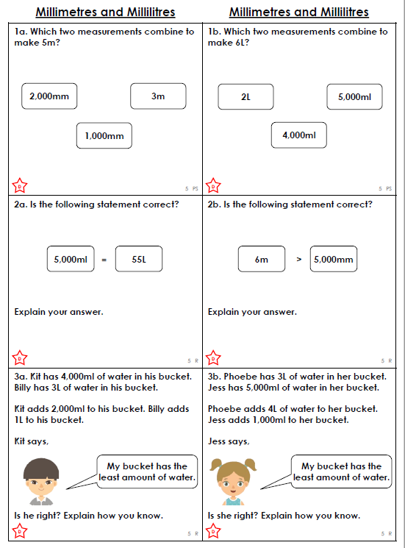

Please show your working out for each question

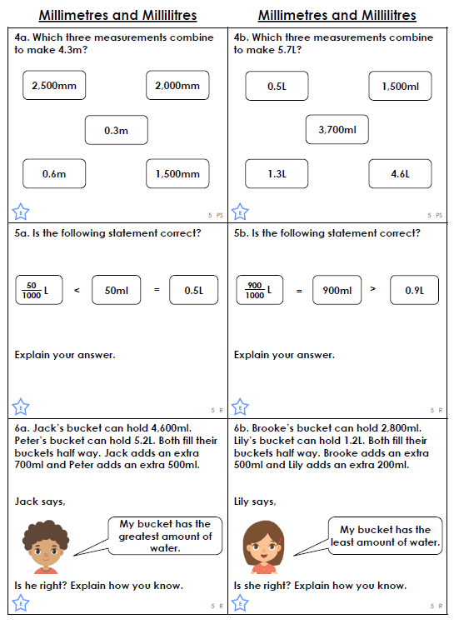

Please show your working out for each question

