Week 6
Monday 27th April 2020
English comprehension – Year 3 & 4
L.O: To answer reading comprehension questions by deducing and inferring information.
Read the extract, then read the questions and find evidence from the text to answer the questions.
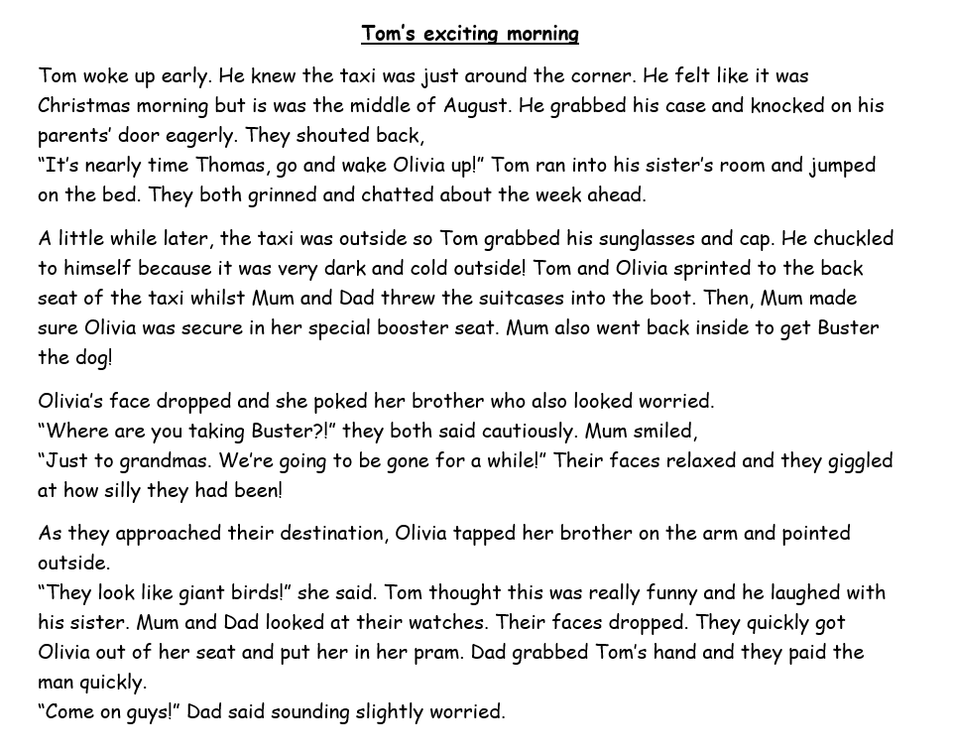

Questions-
Year 3 can answer questions 1 to 5
Year 4 should attempt to answer all the questions.
- Please answer in full sentences e.g. How do we know Tom felt excited in Paragraph One?
- Answer- Tom felt excited in Paragraph One because ……
Questions
- How do we know Tom felt excited in Paragraph One? Try and find all the clues.
- Why do you think Tom chuckled to himself when he went outside in Paragraph Two?
- Where do you think Tom is going? Explain why you think this.
- Pretend you are Tom. Write down how you are feeling and what you are thinking as you travel in the taxi.
- Why has Tom packed sunglasses?
- Why do you think Olivia and Tom were worried when Mum went back into the house to get Buster?
- What do you think Olivia was pointing to when she said “they look like giant birds!”?
- What do you think happened when Mum and Dad looked at their watches in paragraph four?
- Pretend you are Dad at the end of the passage. Write a few sentences explaining your thoughts and feelings.

Week 6
Tuesday 28th April 2020
Grammar and Spellings
LO: To identify nouns and verbs in sentences.
Is It a Noun or Is It a Verb?
Some words can be used as both nouns and verbs, which might get a bit confusing! Try and remember this little trick to help you use these particular words in different ways within your sentences.
The word ‘point’ can be both a noun and verb.
As a noun, it would mean the end of an object such as a sharp point on a pencil.
As a verb, it would mean to point at something using something like your finger.
To use the word ‘point’ as a NOUN, you must put a DETERMINER like ‘a’, ‘an’ or ‘the’ before the word point.
For example: Zaynab sharpened her pencil to a point.
To use the word ‘point’ as a verb, put the word ‘to’ before it.
For example: The little girl started to point out of the school window.

Read these sentences. Is the underlined word being used as a noun or a verb? Please write these sentences in your book and answer next to it.
- Fatima and Maysa stood at the front of the class to present their debate speech.
_________________________

- The teachers gave a present to Issa for learning and memorising all his timetables.
_________________________

- Mum was extremely pleased with the progress Zubayr had made in Year 4.
_________________________

- Rayyan was trying to progress into the 100m relay race.
_________________________

- Zahra was stating to suspect that her little brother had taken the last chocolate biscuit.
_________________________
- After a long chase, Amin finally caught up with the suspect.
_________________________

Now, it’s your turn!

- Write a sentence using the word ‘display’ as a noun.
______________________________________________________________________________________________________________
______________________________________________________________________________________________________________

Write a sentence using the word ‘display’ as a verb.

______________________________________________________________________________________________________________

- Write a sentence using the word ‘wave’ as a noun.
______________________________________________________________________________________________________________
______________________________________________________________________________________________________________

Write a sentence using the word ‘wave’ as a verb.
______________________________________________________________________________________________________________
______________________________________________________________________________________________________________

Week 6
Tuesday 28th April 2020
Spellings
Write and learn the following words in your book.
Write the words 5 times.
Use each word in a sentence.
Do not forget to use a capital letter and full stop in your sentences.
Challenge- can you use at least 2 of the words from the list in a sentence?
Example- I completed my homework in the centre before I left.
- caught
- centre
- century
- certain
- circle
- complete
- consider
- continue

Week 6
Wednesday 29th April 2020
English writing – Year 3 & 4: Task- Write about a special memory between you and your parent/carer.
Look at bear and the cub and for some ideas about what kind of relationship they may have. The questions below will give you some guidance too.
BEAR AND CUB

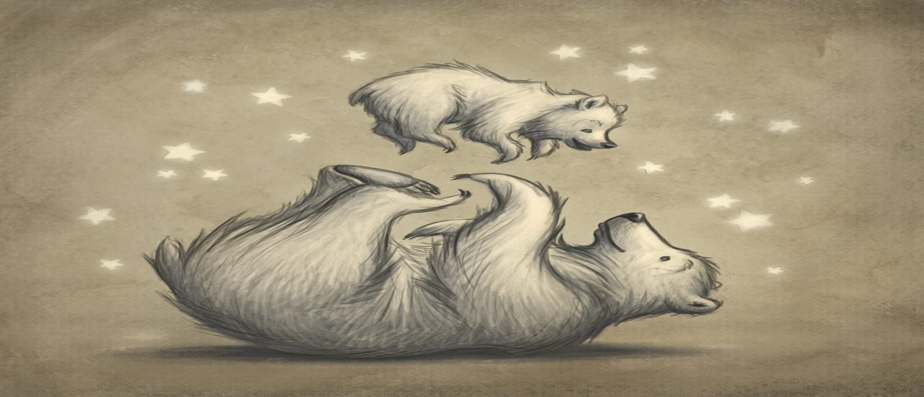
These questions will help you:
- How are you related to this person? How old are they?
- How do you feel about this person?
- Tell us a special moment, which you shared with them? Where/when did this take place.
- What makes them so special?

Task:

Share a special memory between you and this person. Why do you think that time was special?

Do not forget to:
- Use capital letters and full stops.
- Include lots of adjectives (describing words) and adverbs (to describe the verbs)
- Read each sentence to check if it makes sense.
- Open sentences in a wide range of ways for interest and impact.
For example, you can write:
I have a lovely relationship with my mum because I know she loves me, and I respect her so much. She has always been there for me whenever I needed her support.
Notice how my sentences do not always start with I
This is what I mean by different sentence openers.

- Use a wide range of punctuation including at least 3 of the following: full stop and capital, question mark, exclamation mark, apostrophe and comma.
- Use more sophisticated connectives, (e.g. although, however, nevertheless, despite, contrary to, as well as etc).
- Use paragraphs although may not always be accurate.
- Use nouns, pronouns and tenses accurately and consistently throughout.

Year 4

Compare your relationship with your parents/carer with Bear and the cub’s. What are the similarities and differences?
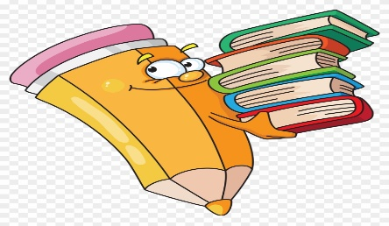
Week 6
Thursday 30th April 2020
Reading and book review – Year 3 & 4
Choose a book to read and answer the following questions about your book.
Book review by: ________________________________________________________
Title:_____________________________________________
Author: ___________________________________________
Non-fiction Fiction
What is the book about?
______________________________________________________________________________________
_____________________________________________________________________________________
Who would this book be suitable for? Age/interests

______________________________________________________________________________________
What was your favourite part? (Describe)
______________________________________________________________________________________
Year 4 challenge: Would you/would you not recommend the book to someone else? Why?

Week 6
Friday 1st May 2020
Comprehension: Read the information text and answer the questions in your home learning book. Make sure you date your work and write the title. Remember answers should be written in full sentences. 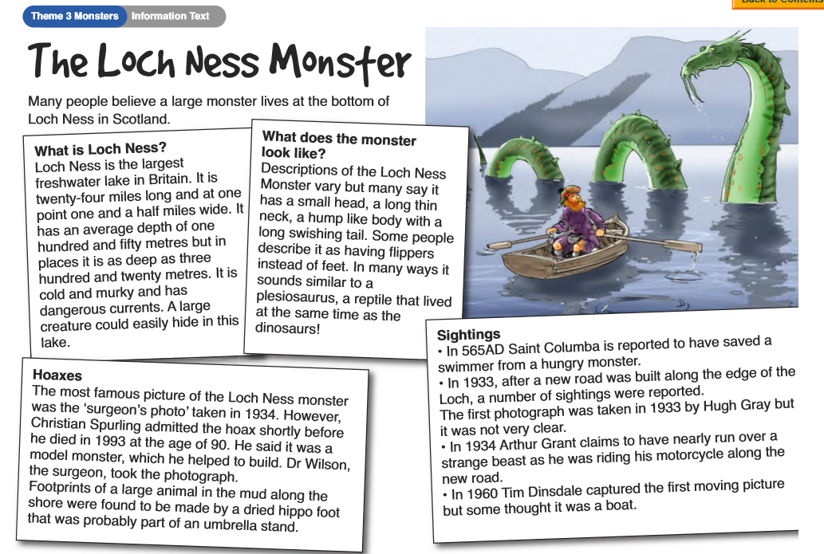

Questions:

  - ‘A large creature could easily hide in this lake’ why is this statement true?

  - Why do you think there were ‘a number of sightings reported’ after a new road was built by the Loch?

  - What is a hoax?

  - Why do you think most famous picture of the Loch Ness Monster was called the surgeon’s picture?

  - Why do you think someone would want to make footprints by the lake using a ‘dried hippo foot’?

Year 4 challenge: Write a description of an imaginary monster which could live in a lake or the sea.
Include:
- Describe the appearance of your monster– Think about its features!
- Height/ size/ colour. What does the monster look like?
- How is your monster similar/different to Loch Ness Monster?

