Early Years Islamic Studies Weekly Plan
w/c 27th April

Daily Quran, duahs and qaida recitation 9.30 - 9.45am

- Read Waking up dua together with actions and meaning
"All praise is for Allah who woke us up after going to sleep"

- What is the name of the first surah in the Quran?
Model language: “The first surah in the Quran is Surah Fatiha and we recite it in our prayers”. Then Recite Surah Fatiha together.

- Recite the 4 Quls: Currently memorising the fourth Qul: Sural Al kafiroon on ayah no 4.
Nursery children should all know Surah Fatiha and Ikhlas , Surah An-nas and Falq.
Reception children are at different levels so please practice all surahs memorised so far and proceed with the next surah for 10 min.

Jummah
- Practice Surah Kahf memorisation. Depending on where your child is currently at. Most children have memorised 4 ayahs.
- Plant Jannah trees by doing dhikr of Subhan Allah, Alhamdulillah, Allahu Akbar, Laillaha illalallah, Astaghfirullah. We plant 5 Jannah trees by saying the dhikr 11 times. Your child will know how to plant them. They make themselves like small round seeds in the ground and then grow by using the 'one potato, two potato' action to make themselves blossom into trees by standing tall.
- Parents to read Durood-e-Ibrahim with your child. Parents to say it word by word or line by line and then children can repeat it after you. Make it a habit every Jummah
- Prophet Stories - See Friday section on the last page.

Things to do during the day as reminders:
- Toilet Run - recite duahs. We do toilet run at 10am 11am and 2pm. Please recite duahs before going in and recite Gufranaka when leaving toilet.
- Lunch Duahs Recite eating dua together. After lunch recite the after eating dua together with actions. Practice Surah al kafiroon for 5min or the Surah your child is struggling with.
- Reminder to Recite Sleeping Duah before bed with actions "Oh Allah with your name I go to sleep and wake up" (This is a child friendly interpretation so they can understand the meaning easily)

Islamic Studies
Every week we will send you a different topic to discuss with your child. See attached activity sheets to read and colour each day in the following order.
This week's topic is Allah's 'Creations' : Say "C, C Creation" child to repeat

Monday -
- Allah created / made everything that you can think of (Read attached creation resource)
- Talk to your child about all the different things Allah has created / made
- Watch and Sing along to Nasheed - Allah Created Everything by Zaky
https://www.youtube.com/watch?v=gXQqXcXck4k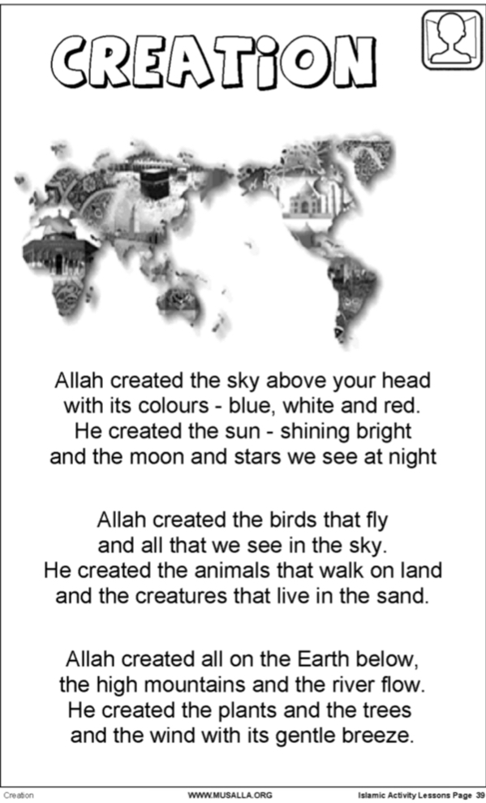

Tuesday - Recap Mondays Lesson. Read Creation resource again. Say and children to repeat "C, C Created". Watch YouTube nasheed Allah Made Everything - Zain Bhikha
https://www.youtube.com/watch?v=klZJcX9YtnQ

- Talk about the different things Allah has created. Look /colour or Draw the following resource and ask : What things can you see that Allah has created? Encourage children to say answer in full sentences. Model language

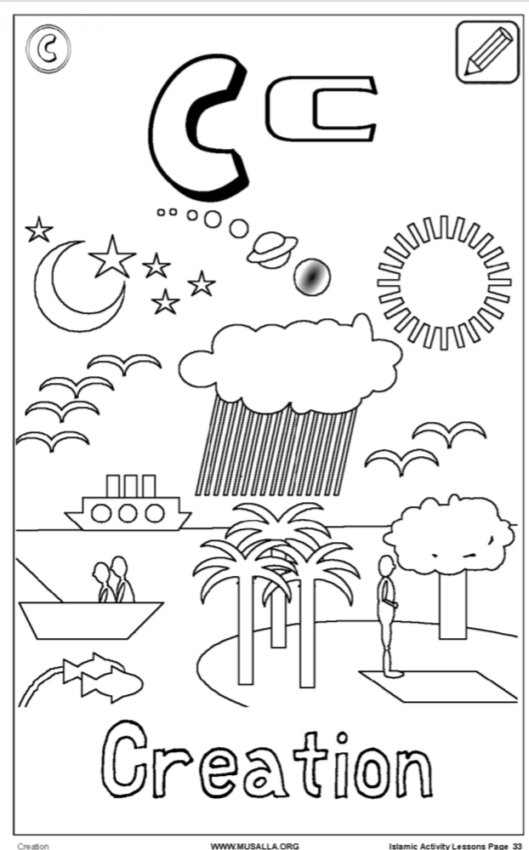

Wednesday - Recap Mon/Tue lessons and ask children to recall all the different things Allah has created. Say and children to repeat "C, C Created". Watch nasheed Everything Belongs to Allah - Zain Bhikha
https://www.youtube.com/watch?v=ztjEkGIHY5w

- Read following resource and ask child to recall 'What things has Allah created? Encourage children to say answer in full sentences. Model language

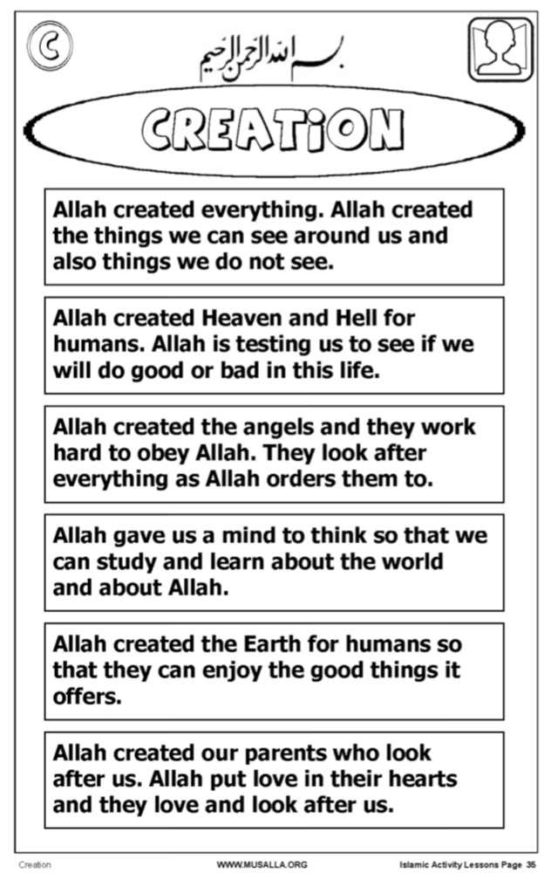

- Fill in the following resource with your child or write on paper.
Reception: Parents to help children write out simple words using their phonics sounds
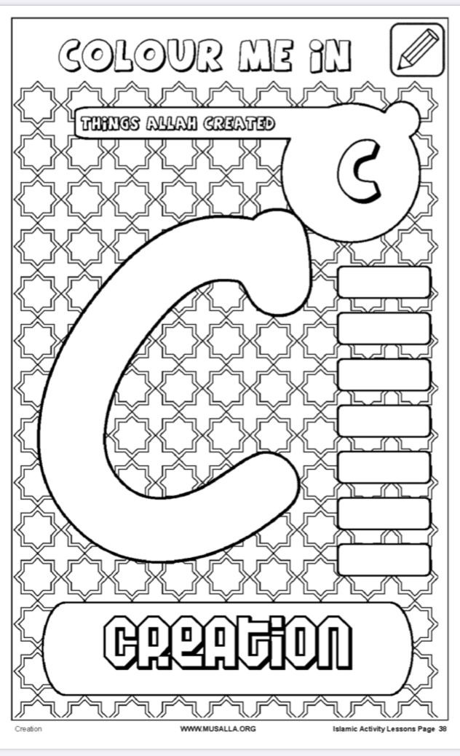

-

Thursday - Recap the weeks lessons using previous resources. Ask children to recall all the different things Allah has created. Say and children to repeat "C, C Created".

Watch nasheed Cotton Candy Sky – Zeebee Kids
https://www.youtube.com/watch?v=jc5yyqtyXqI
- Read following resource and ask child to recall 'What things can has Allah created under each heading. Reception: Parents to help children write out simple words using their phonics sounds

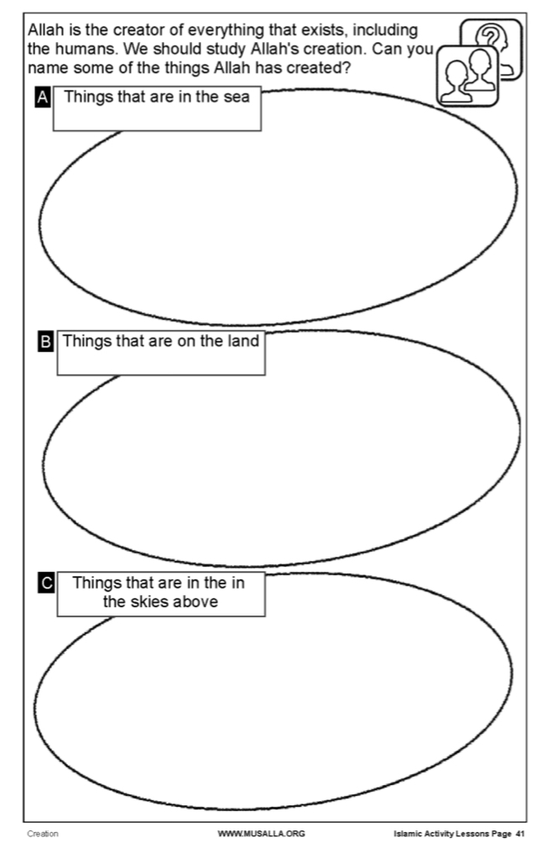

Friday / Jummah

Prophet Story time - Listen to the story of Nūḥ ʿAlayhis salām on YouTube
Ask your children questions along the way

Encourage children to say answer in full sentences. Model language

https://www.youtube.com/watch?v=sstafD6UmFk&list=PLUpqHCJMOGtOXW6ycO6ZsIPMWMWHzmPC0&index=3

What did Allah tell Nūḥ ʿAlayhis salām to build? A boat

What did Allah tell Nuh ʿAlayhis salām to take on to the boat? Two of every animal

What did the rain do? The rain destroyed everything

How long did it rain for? 40days and 40 nights

