Week 5
Wednesday 22nd April 2020
Year 5
Varied fluency

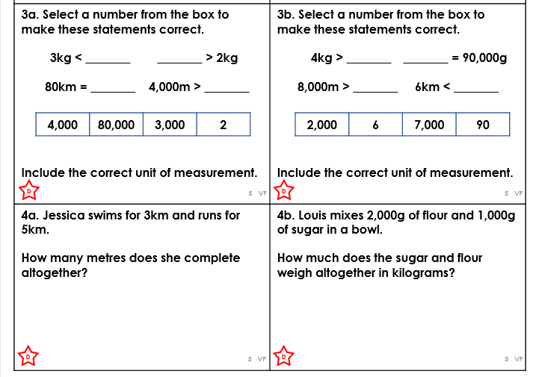

Please show all your working out on how you got to your final answer for the word problems.

