Week 5
Tuesday 21st April 2020
Year 5
Varied fluency
Click here for more information:
https://www.bbc.co.uk/bitesize/topics/zqr4jxs/articles/z4j88xs

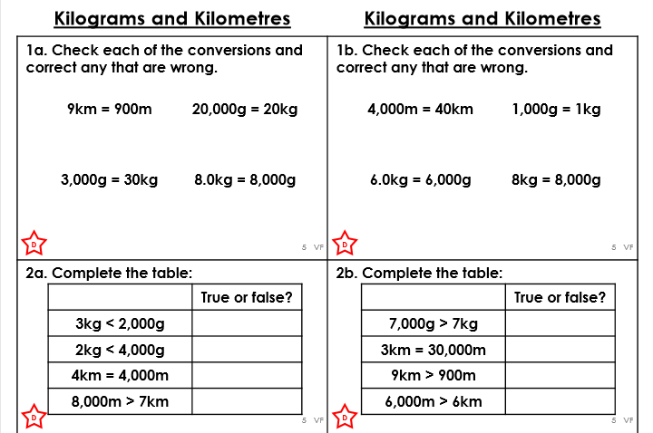

Make sure you give reasons for why you agree if something is true or false.

