Goldilocks and the three bears
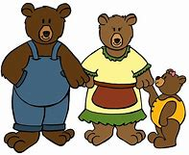
Read the story goldilocks and the three bears

What size is daddy bear? What size is mummy bear? What size is baby bear?
Match the word with the picture

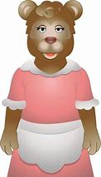
Big

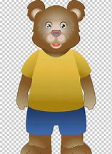
Medium

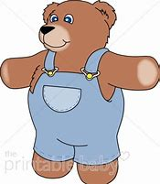
Small

Ask the children questions
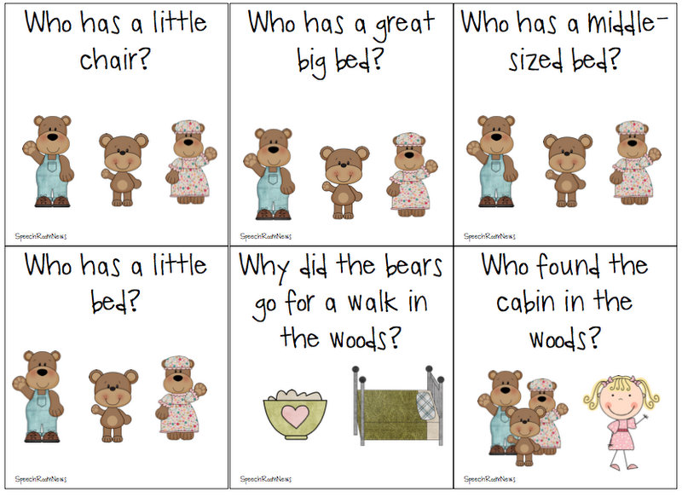

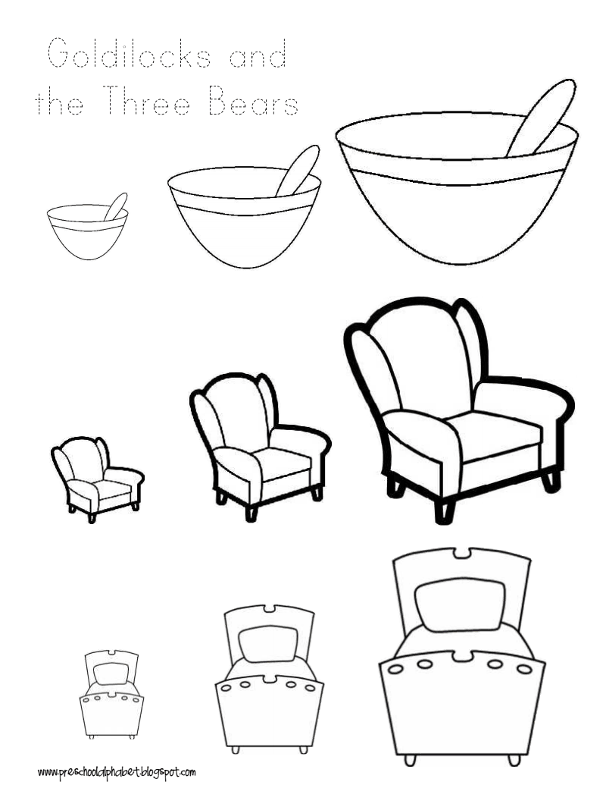

Colour the pictures

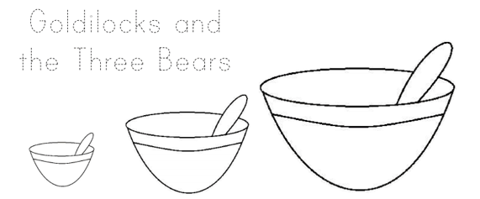

Show them three different size bowls and ask the children to tell you which one is big, medium and small.
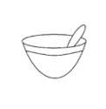
Which bowl is big?
1.

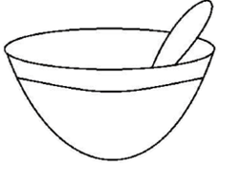

Which bowl is medium? 2.

Which bowl is small? 3.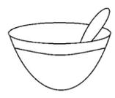

Look around your house and see if you can find something big, medium and small.

Draw the big item

Draw the medium item

Draw the small item

