Week 5
Wednesday 22nd April 2020
Year 6
Varied fluency

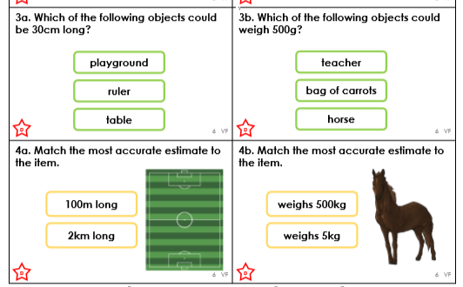

Make sure you give your reasons for why you have selected that answer.

