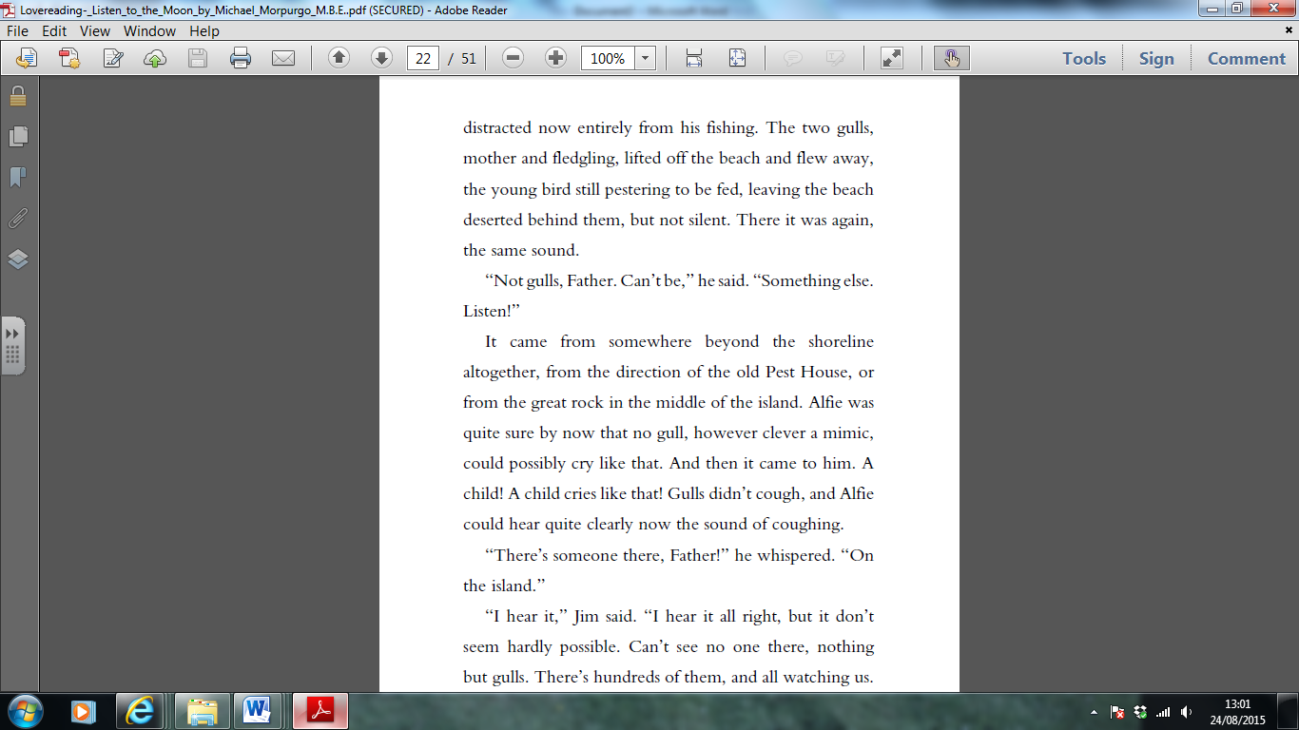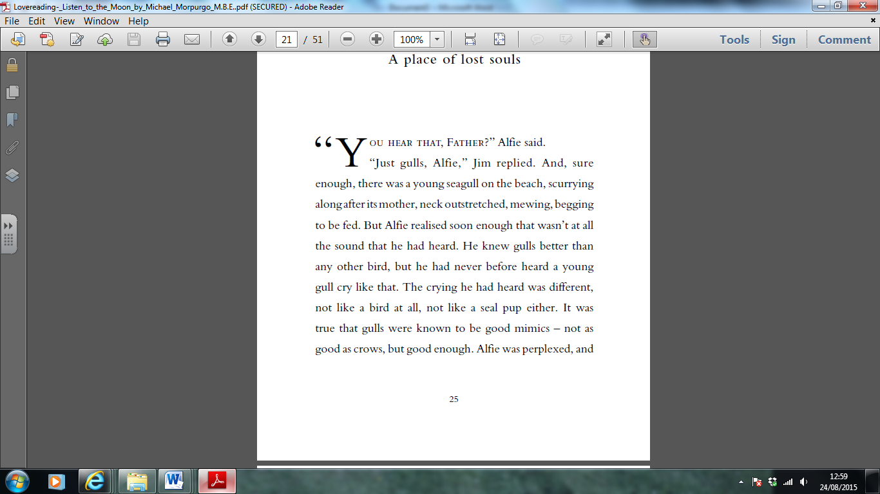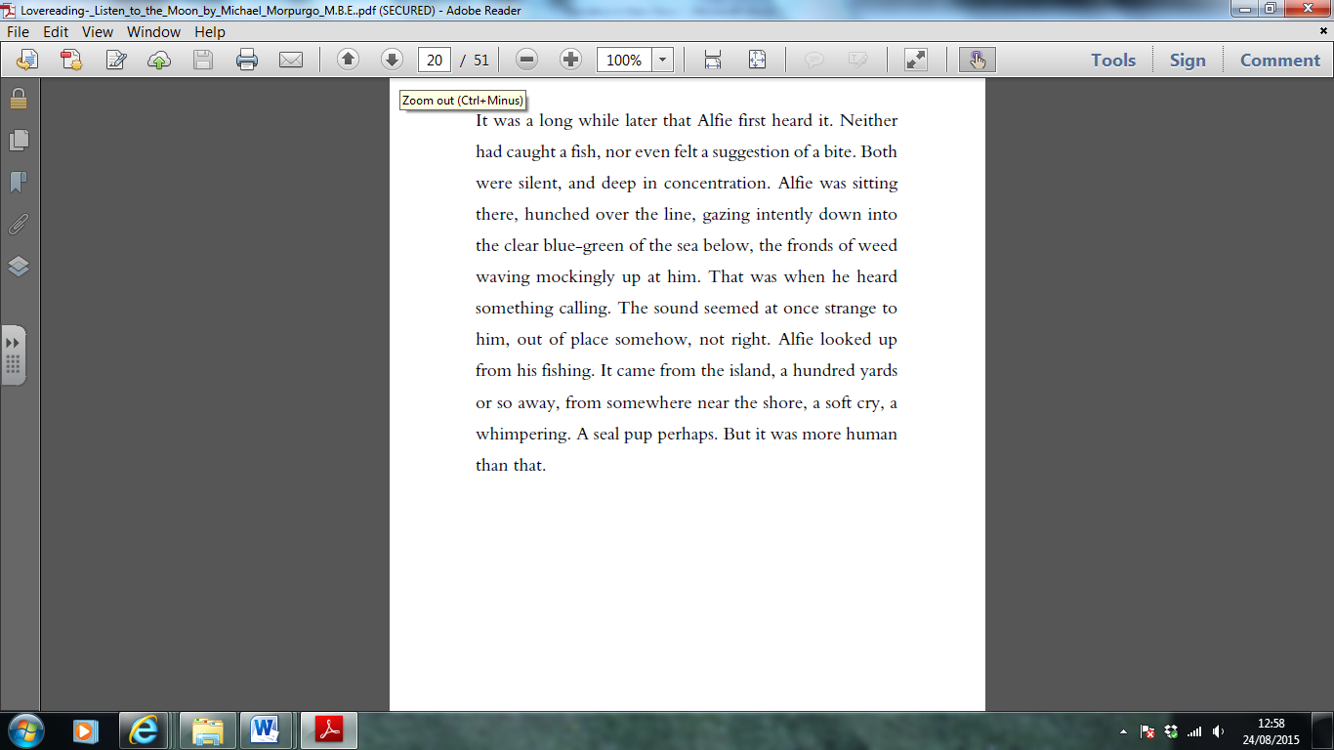 Week 5 Friday 24th April 2020 **English comprehension**

**From ‘Listen to the Moon’ by Michael Morpurgo**

**Yr 5- Answer questions 1-7**

**Yr 6- Answer questions 1-9**

**Retrieving Information**

1. Use a dictionary to find the definition of:
2. fronds
3. intently
4. perplexed
5. Find and copy a word that shows the noise that Alfie hears is a sad one.
6. What is the relationship between Jim and Alfie?

**Making Inferences**

1. How do you know that Alfie spends a lot a time out on the coast?
2. Have Alfie and Jim just arrived or have they been out for a while? How do you know?
3. Why do you think that Alfie whispers to his father at the end of the extract?

**Writer’s choices**

1. Why do you think the writer has started with the line, “It was a long while later that Alfie first heard it.”? What mood does this create?
2. Why do you think the author describes the weed as “waving mockingly”?

**Challenge question**

1. Why might Jim think that is not possible for a child to be on the island?