Carefully, read and answer the questions using the classification systems in this activity pack.

*There are two classification systems and two sets of questions; make sure you are using the appropriate classification system to answer the right questions.

Activity pack 1:
Carl Linnaeus and His Classification System
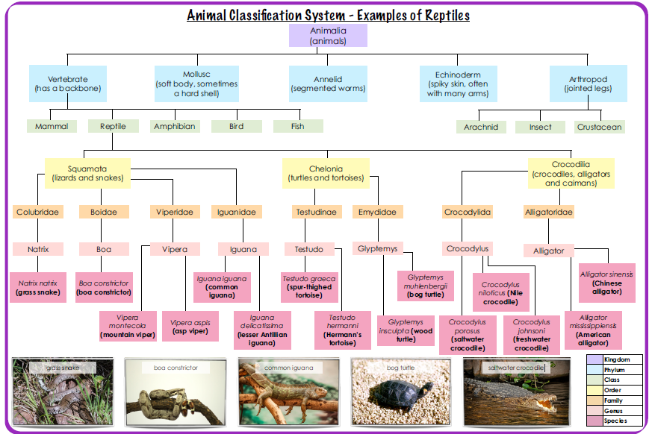

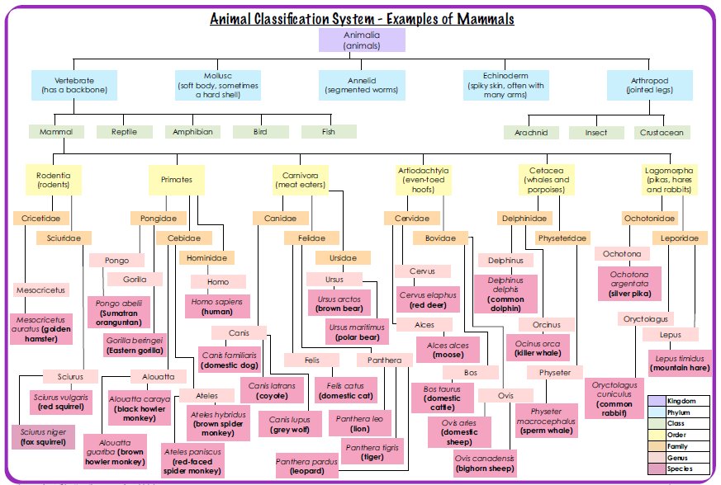
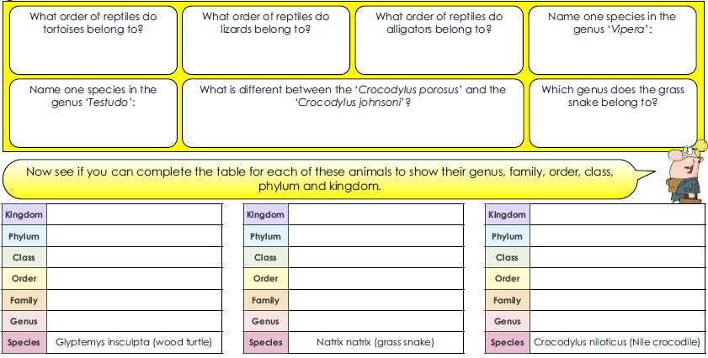

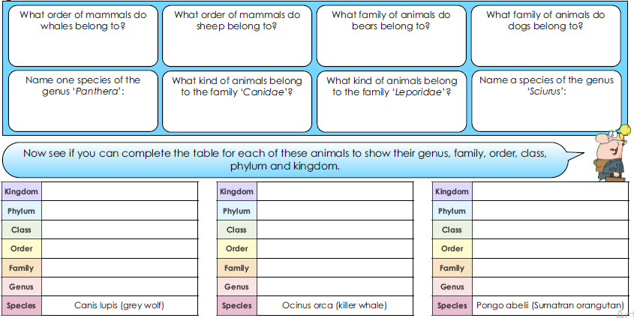

Challenge Questions

- In which family of animal would you expect to find jaguars? Why?

- In which family of animal would you expect to find European rabbits? Why?

- What would you say is the main difference between animals in the family ‘Pongo’ and ‘Gorilla’?

- How would you explain the similarities and differences between the genera ‘Cervus’ and ‘Alces’?

Now choose two animals and complete one of the tables below for each one. 