Phonics
All children will benefit from watching ALPHABLOCKS on YouTube along with playing interactive games on the websites below. Please follow the link
NURSERY: Nursery children should play phase one phonics interactive games found on the links below unless they are in phase 2, 3 or 4 please follow the reception guideline.
RECEPTION: All children who are on phase 2, phase 3, phase 4 please practice writing the sounds and reding them in words.
For phonics you could play interactive games on https://www.phonicsplay.co.uk/ on the free phonics play section.
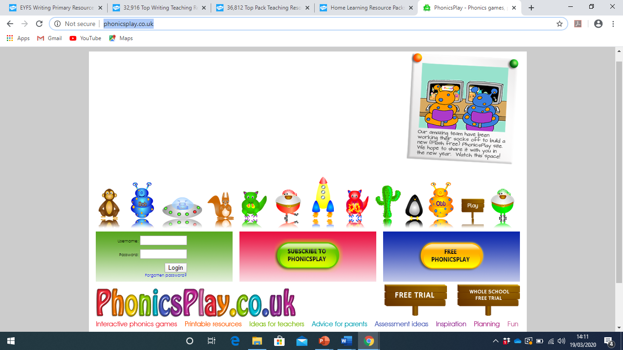
Or visit https://www.topmarks.co.uk/english-games/3-5-years/letters-and-sounds
