Buttercup/Evergreen Primary school
Reception week 1 (23.03.2020)
Letters and Sounds
Parent Weekly Newsletter
Phase 3  New tricky words this week  and like | This week introduce your child to the Phase 3 Tricky Words.  Tricky words are words which cannot be sounded out correctly using the Jolly Phonics sounds. The only way these words can be read and spelt correctly is by learning them and having plenty of practise. |  | Sounds already learnt
Phase 3  New tricky words this week  and like |  |  | ch, sh, th, qu, ng, nk, ai, ee, igh, oa, or, ur, oo, ow, oi
Captions to read
- Snail in the rain
- Goat in a boat
- Nurse with a purse
- Look at the book
- What can you see?

Tricky words already learnt:  you, my, me, into, was |  | 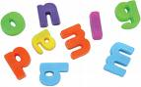 Activities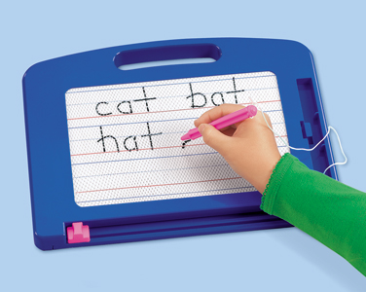
Please also continue to support your child with reading and writing CVC words using the sounds they have learnt this year.  Blending and segmenting CVC words such as yes, dip, rat, tin, mop, got, will still be a daily focus within our phonics sessions. |  | - Magnetic Letters  - Little whiteboards and pens, and magic boards  - Make your own flash cards (play snap, pairs)  - Form letter in chalk, sand, outside, etc.
Internet Games
http://www.phonicsplay.co.uk/BuriedTreasure2.html
http://www.phonicsplay.co.uk/PictureMatch.html

