Buttercup/Evergreen Primary school
Nursery week 1 (23.03.2020)
Letters and Sounds
Parent Weekly Newsletter
Phase 2  New tricky words this week  into no | This week introduce your child to the Phase 2 Tricky Words.  Tricky words are words which cannot be sounded out correctly using the Jolly Phonics sounds. The only way these words can be read and spelt correctly is by learning them and having plenty of practise. |  | Sounds already learnt
Phase 2  New tricky words this week  into no |  |  | s a t p  i m n d  g o c k  ck e u r b h  f ff l ll ss
Captions to read
- into the sun
- go into the mud
- go into the den
- yes and no
- no it is not

Tricky words already learnt:  I the you to go |  | 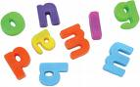 Activities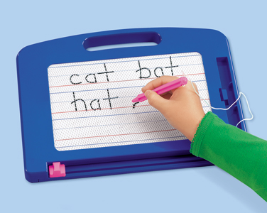
Please also continue to support your child with reading and writing CVC words using the sounds they have learnt this year.  Blending and segmenting CVC words such as yes, dip, rat, tin, mop, got, will still be a daily focus within our phonics sessions. |  | - Magnetic Letters  - Little whiteboards and pens, and magic boards  - Make your own flash cards (play snap, pairs)  - Form letter in chalk, sand, outside, etc.
Internet Games
http://www.phonicsplay.co.uk/BuriedTreasure2.html
http://www.phonicsplay.co.uk/PictureMatch.html

