Early Years Islamic Studies Weekly Plan
w/c 23rd March

Daily Quran, duahs and qaida recitation 9.30 - 9.45am

- Read Waking up dua together with actions and meaning
"All praise is for Allah who woke us up after going to sleep"

- What is the name of the first surah in the Quran?
Model language: “The first surah in the Quran is Surah Fatiha and we recite it in our prayers”. Then Recite Surah Fatiha together.

- Recite the 4 Quls: Currently memorising the fourth Qul: Sural Al kafiroon on ayah no 4.
Nursery children should all know Surah Fatiha and Ikhlas , Surah An-nas and Falq.
Reception children are at different levels so please practice all surahs memorised so far and proceed with the next surah for 10 min.

Jummah
- Practice Surah Kahf memorisation. Depending on where your child is currently at. Most children have memorised 4 ayahs.
- Plant Jannah trees by doing dhikr of Subhan Allah, Alhamdulillah, Allahu Akbar, Laillaha illalallah, Astaghfirullah. We plant 5 Jannah trees by saying the dhikr 11 times. Your child will know how to plant them. They make themselves like small round seeds in the ground and then grow by using the 'one potato, two potato' action to make themselves blossom into trees by standing tall.

Things to do during the day as reminders:
- Toilet Run - recite duahs. We do toilet run at 10am 11am and 2pm. Please recite duahs before going in and recite Gufranaka when leaving toilet.
- Lunch Duahs Recite eating dua together. After lunch recite the after eating dua together with actions. Practice Surah al kafiroon for 5min or the Surah your child is struggling with.
- Reminder to Recite Sleeping Duah before bed with actions "Oh Allah with your name I go to sleep and wake up" (This is a child friendly interpretation so they can understand the meaning easily)

Islamic Studies
Every week we will send you a different topic to discuss with your child. See attached activity sheets to read and colour each day in the following order.

This week's topic of discussion is Who is Allah?
Tuesday As Salaam - Read with your child. Nursery children to listen while you point out the rhyming words and reception children to pick out rhyming words whilst you read and they listen. Children can colour in 'As Salaam' Sheet. Ask children - Who made all the people around the world? "Allah" and how Allah has made us all different.

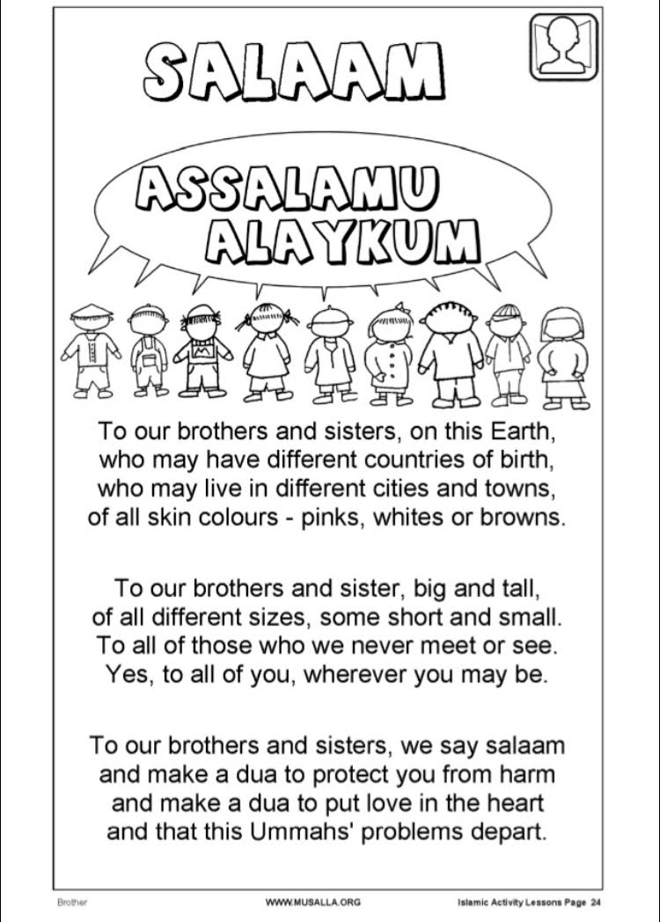

Wednesday - Use sheet 'Who is Allah?' to talk to your child about Allah. Colour in 'A is for Allah Arabic' sheet. Ask reception children to copy in arabic الله

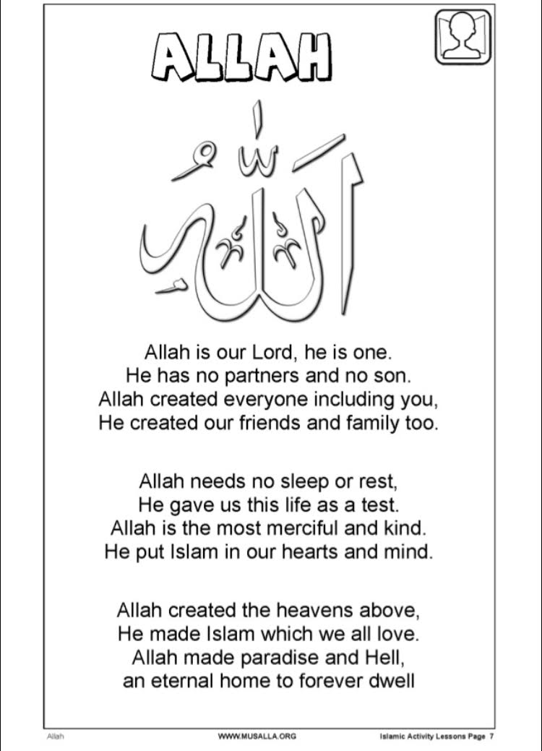

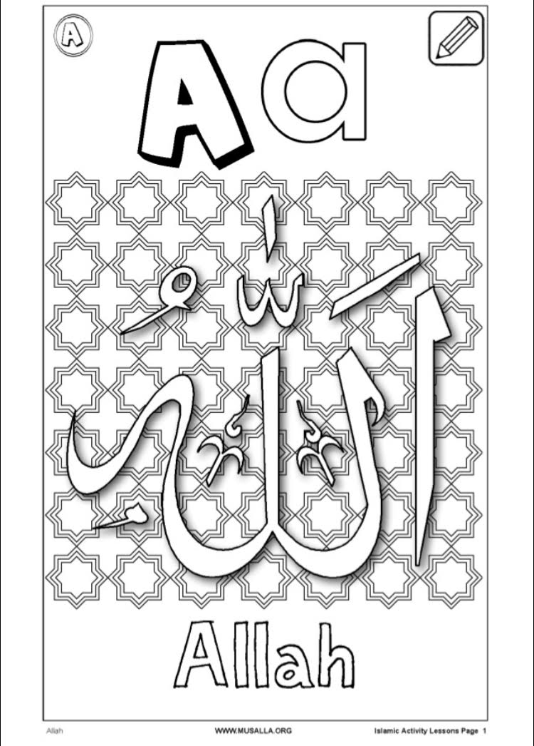

Thursday: Use sheet 'Who is Allah?' Sheet from Wednesday to talk to your child about Allah again. Colour 'A is for Allah colour and write'. Ask your child how to spell Allah. Sound the letters out. Children to copy Allah or sound it out. Nursery children can go over the 'a' using the 'round the apple, down the leaf'

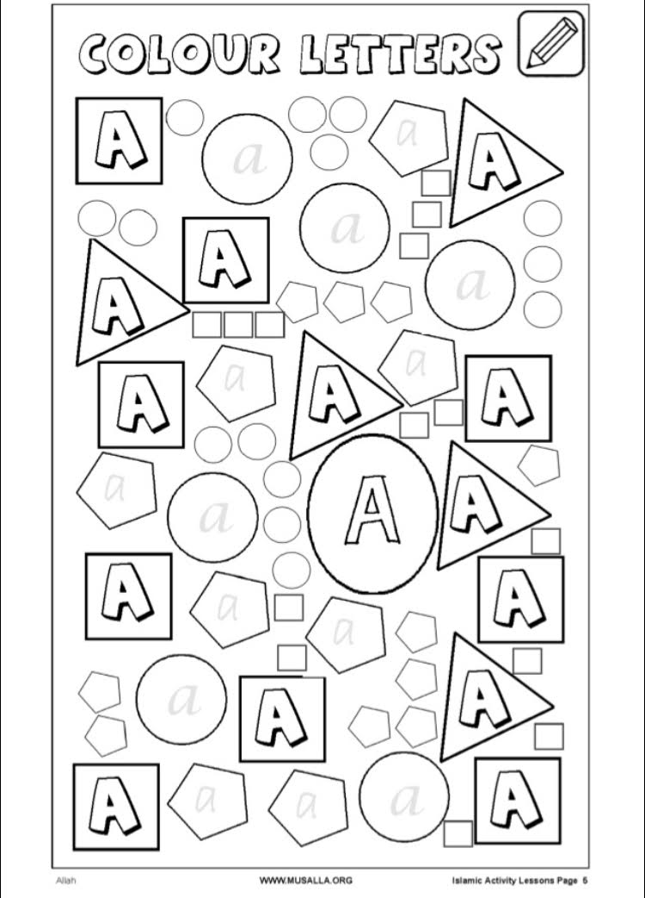

Friday / Jummah - Use sheets 'Allah’s Attributes' to talk about who Allah is. Then fill in Names of Allah and colour.
