**Literacy**

I will be learning to recognise and write my name.

• I will be learning to write familiar words such as mum, baby, dad, family, see, went

• I will be writing about myself and my family.

• I will be learning to write for a purpose e.g. making lists, labelling pictures, writing a letter.

• I will be reading a range of fiction books

• I will be learning different sounds that letters make (phonics)

• I will be learning to blend sounds together to make simple words.

**Nursery & Reception Autumn 1***- 2019*

**We will ensure that Islamic knowledge is incorporated into the curriculum In Shaa Allah.**

**Autumn Term Curriculum Overview**

**Topic: Ourselves/Changes**

**Personal, Social and Emotional Development**

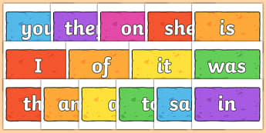

**Mathematics**

• I will be creating class rules with my friends.

• I will be participating in turn taking games.

• I will be trying out new activities independently and select resources independently.

• I will be dressing and undressing independently for P.E.

• I will be learning routines of the school day.

• I will be learning to think about the feelings of others.

• I will be learning and talking about my family and other people who are important to me.

I will be learning to count, recognise and order numbers to at least 5 or 10.

• I will be learning to match numbers to quantities of groups to at least 5 or 10.

• I will be learning to say the number one more/less than a given number up to 5 or 10.

• I will be learning to name and describe simple 2D.

• I will be sorting shapes and objects by colour and size.

• I will be learning to create repeating patterns.

• I will be comparing sizes of different objects.

• I will be ordering the events in my day.

**Communication & Language**

I will be learning to talk about myself using describing words such as tall, short.

• I will be imagining and recreating roles in real life family situations and fictional stories.

• I will be asking questions to get to know my friends in my new class.

• I will be talking about my family.

• I will be thinking about sequence of events in stories and saying what happened in the beginning, middle and end.

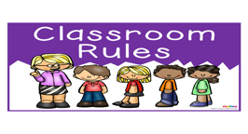

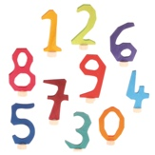

**Understanding the World**

**Expressive Arts & Design**

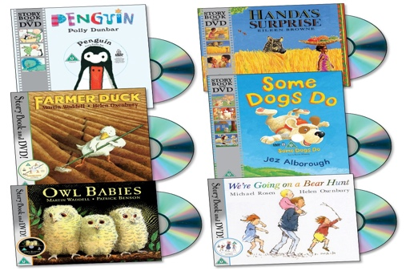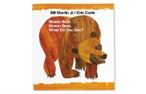

• I will be using a computer to help me in my learning.

• I will be using all five senses to investigate the world around me.

• I will be recognising similarities and differences between myself and others.

• I will be going on local walks around the school.

• I will be learning about different parts of the body.

• I will be learning about the differences between light and dar

I will be drawing pictures of myself using mirrors.

• I will be drawing pictures of my family.

• I will be thinking about colours, mixing colours and using them appropriately in my pictures.

• I will be using a range of objects to print with e.g. hands, sponges.

• I will be learning new songs to help me in my learning.

• I will be roleplaying in the home corner.

• I will be acting out stories with puppets.

• I will be using a range of materials to make collages and models.

**Physical Development**

I will be using tools safely.

• I will be learning about how to be healthy.

• I will be describing the changes my body after being active.

• I will be moving with control and co-ordination over, under, through various small apparatus.

• I will be using a range of small and large equipment.

• I will be using a range of malleable materials in my play.

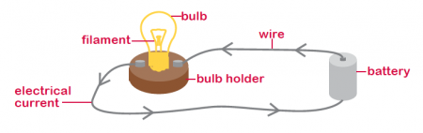

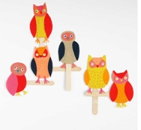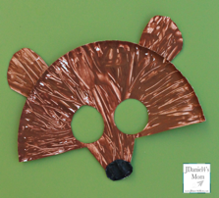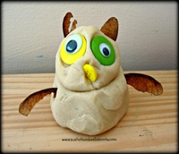

**Fiqh**

Suarahs

Tajweed

**Qur’an**

